Name: Block:
ACROSTIC POETRY
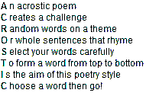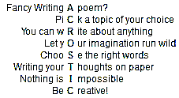
Definition for acrostic poetry:

You have probably already written an acrostic poem sometime during Elementary school. Your task is to amp up your game and write something beyond just a repetition of your name. Pick a word or phrase that describes you, a person in history, a current event, or a controversial issue that you can expand upon (for example, Donald Trump, MMA, or eccentric).
Here are some more involved acrostic poems:

Elizabeth it is in vain you say
'Love not' — thou sayest it in so sweet a way:
In vain those words from thee or L.E.L.
Zantippe's talents had enforced so well:
Ah! if that language from thy heart arise,
Breath it less gently forth — and veil thine eyes.
Endymion, recollect, when Luna tried
To cure his love — was cured of all beside —
His follie — pride — and passion — for he died.

-- 'An Acrostic', by Edgar Allan Poe

Set among hills in the midst of five valleyS,
This peaceful little market town we inhabiT
Refuses (vociferously!) to be a conformeR.
Once home of the cloth it gave its name tO,
Uphill and down again its streets lead yoU.
Despite its faults it leaves us all charmeD.

-- by Paul Hansford

Your Turn! Record a word that you would like to make an acrostic poem about and begin writing a draft on the backside:

