6 anti-Muslim incidents in Ontario since Paris attacks

'I feel like we're being judged for something we had nothing to do with,' Shara Fathima tells CBC
CBC News Posted: Nov 21, 2015 5:00 AM ET Last Updated: Nov 21, 2015 1:38 PM ET
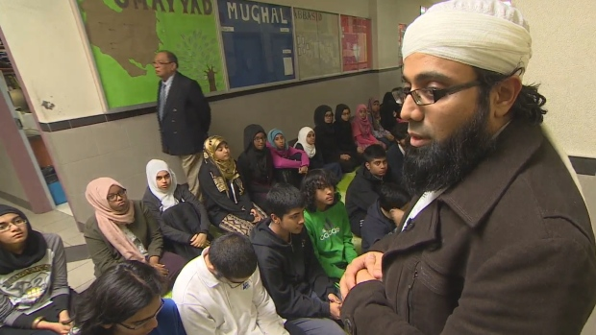
Imam Yusuf Badat talks to students at the Islamic Foundation of Toronto in Scarborough about the recent string of anti-Muslim attacks in the region. (CBC)
There has been an uptick in reported hate crimes targeting Muslims and others in Ontario since ISIS took responsibility for the Paris attacks last week.
"I feel like we're being judged for something we had nothing to do with," Shara Fathima told CBC News on Friday during a march in Toronto, where hundreds gathered to call for peace after a string of attacks in and around the city.
- Young Quebec Muslims search for answers after Paris
- Wynne offers support after anti-Muslim attacks
- Toronto says #IllRideWithYou to Muslims after racist attacks
Even children are on edge, with students at the Islamic Foundation of Toronto in Scarborough telling CBC News they feel frightened and helpless in the face of these attacks.
"You really realize it could happen to any one of us," said Sara Ahmad, 17.
Here's a look at some of the incidents:

Mosque set ablaze
On Nov. 14, a fire broke out at the Kawartha Muslim Religious Association's mosque in Peterborough, Ont., causing $80,000 in damage. Police say the fire was intentionally set and they are investigating the arson as a possible hate crime.

Hindu temple vandalized
The following evening, Nov. 15, police say someone heaved five stones through the two window panes at the Ram Dham Hindu temple in Kitchener. Investigators aren't calling the vandalism a hate crime, or drawing links to the Paris attacks, but say both remain a possibility until police can identify and question a suspect.

U of T student allegedly spat on, insulted
That same weekend, a Muslim student at the University of Toronto claims he was spat on and insulted in what appears to have been a racially charged attempted assault outside Robarts Library. The student said the man spat directly into his face and told him to take his turban off. He was, in fact, wearing a topi — a short, rounded skullcap worn in many Islamic communities.

Woman robbed, beaten
On Monday, police say a Muslim woman was attacked and robbed mid-afternoon outside a Toronto elementary school by two white men who reportedly called her a "terrorist" and told her to "go back home," as they pulled on her hijab and punched her in the stomach before making off with her cellphone and money.

Hate mail in Ottawa
On Wednesday, an Ottawa woman told police she found a note in her mailbox, telling her to "go back home" because Canada "is no place for terrorists or immigrants." Eren Cervantes-Altamirano said she has no idea who penned the handwritten note.

Women accosted on TTC
Two Muslim women were accosted and verbally assaulted on a Toronto subway train on the evening of Nov. 18, the Toronto Transit Commission said. Two men and a woman boarded a train and proceeded to make racist comments about the two Muslim women, including an implication that they could be terrorists, TTC spokesman Brad Ross said. The woman allegedly pushed one of the Muslim women. One of the suspects has since been identified as a minor.

