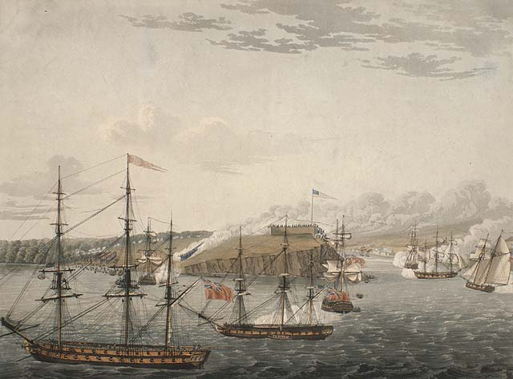
Attack on Fort Oswego, Lake Ontario, N. America. May 6th, 1814, Noon.
Credit: Library and Archives Canada, c000794k (1815)
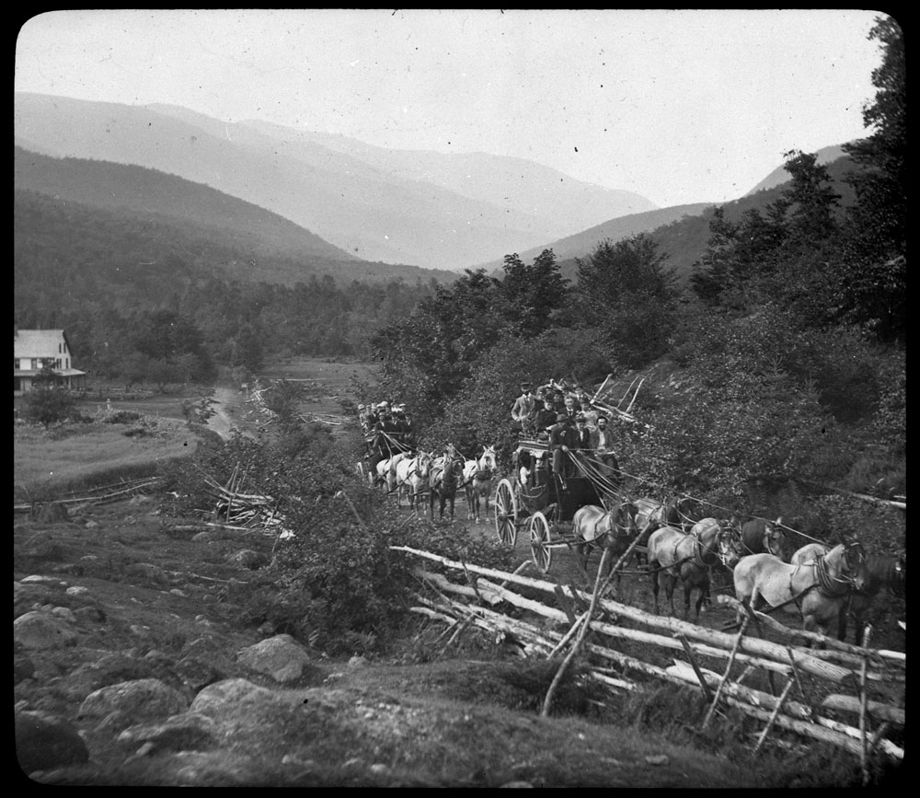
[Stagecoaches] c. 1800-1900.
Credit: Denley, Norman / Library and Archives Canada / PA-066580
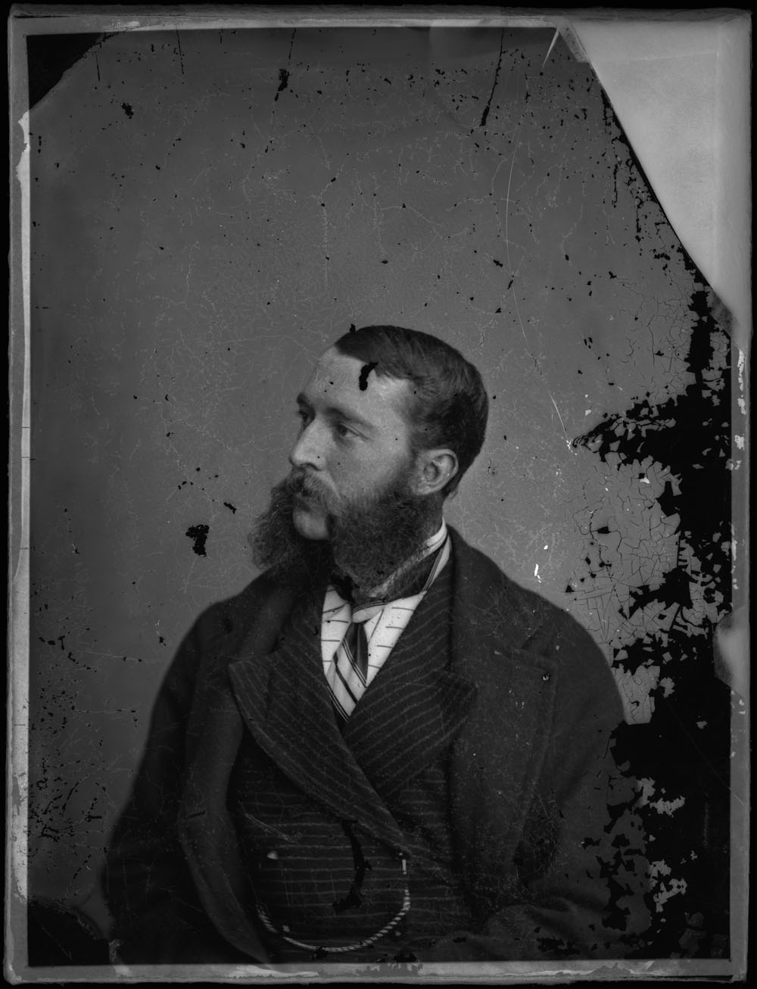
Glancey Mr. (in 1800 Series)
Credit: Topley Studio / Library and Archives Canada (1868)
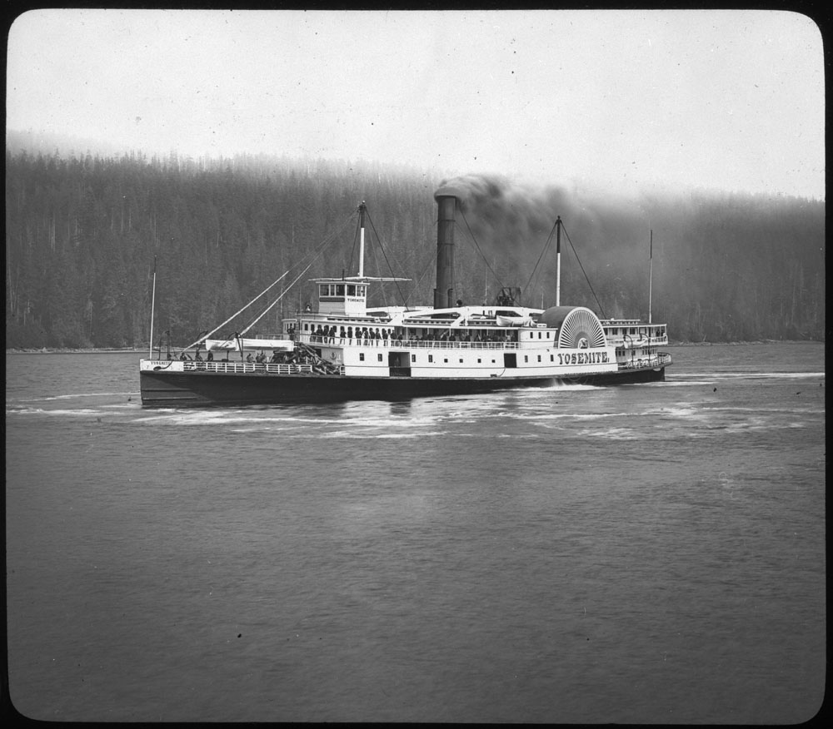
The "Yosemite" [1800 - 1900].
Credit: Denley, Norman / Library and Archives Canada / PA-066551

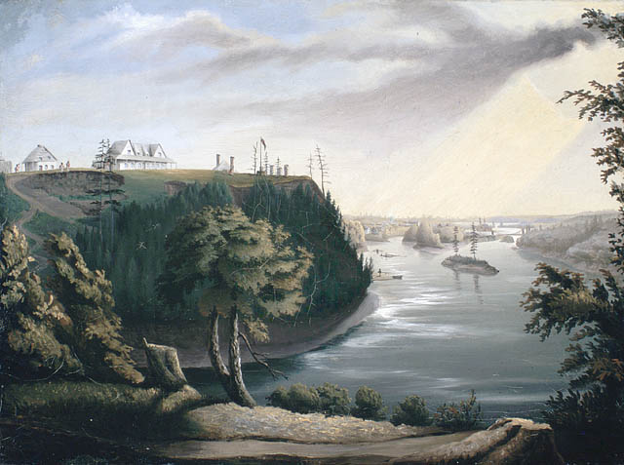
View of Barrack Hill and the Ottawa River at Bytown (Ottawa)

Credit: Library and Archives Canada, Acc. No. 1991-120-3 (ca. 1843-1859)
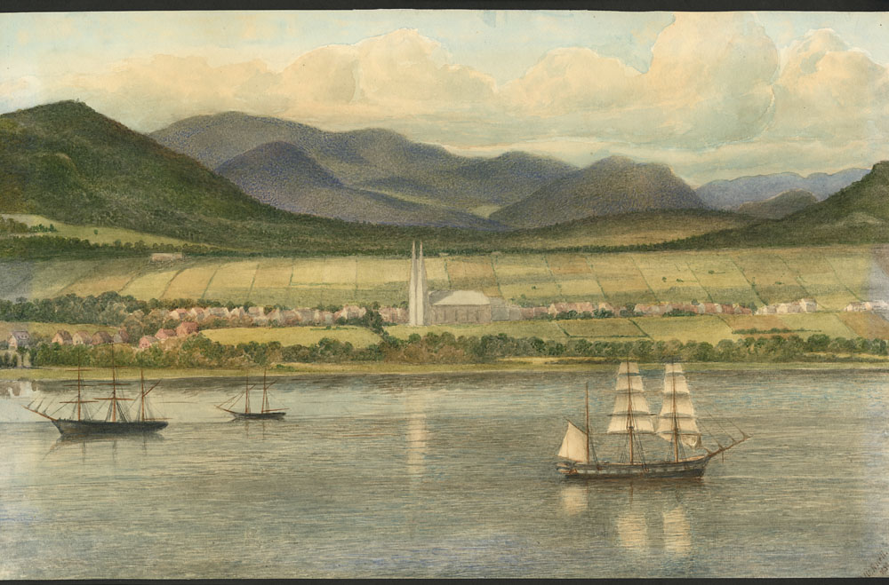
A Village along the Lower St. Lawrence river.
Credit: Library and Archives Canada, Acc. No. 1988-313-2 (1830)
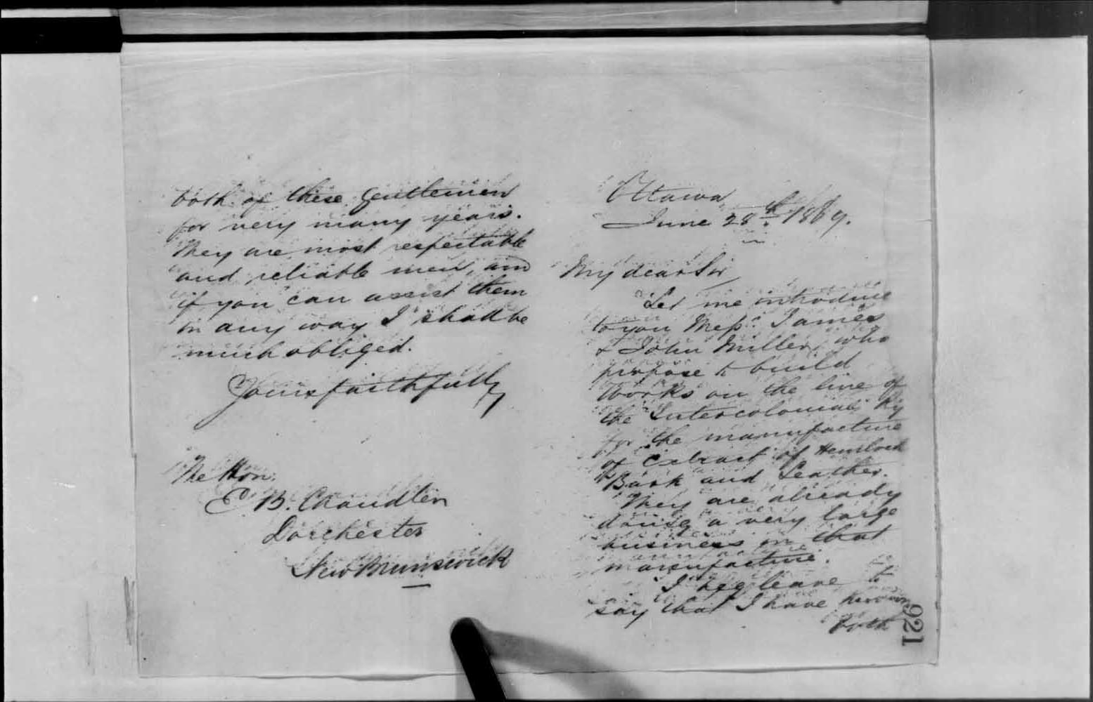
[Correspondence] [textual record]
June 28, 1869

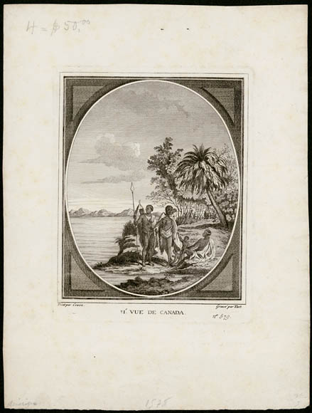
Ie. Vue de Canada (First View of Canada)
Credit: Library and Archives Canada / Bibilothèque et Archives Canada (R9266-2378) Peter Winkworth Collection of Canadiana (ca. 1780)

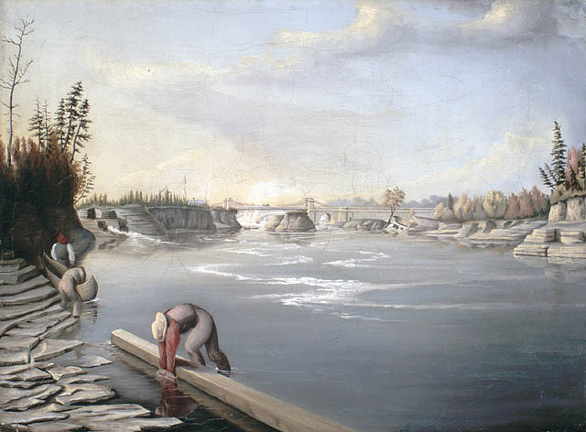
Vue des ponts Chaudière sur la rivière des Outaouais, à Bytown (Ottawa)
Crédit: Bibliothèque et Archives Canada, no d'acc 1991-120-2 (ca 1843-1859)
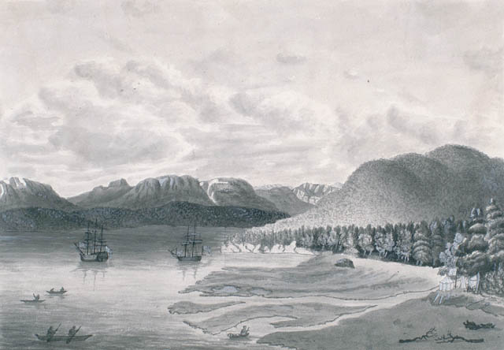
Salmon Cove, à Observatory Inlet, Prince Rupert.
Crédit: Bibliothèque et Archives Canada, no d'acc 1981-55-8 (1818)

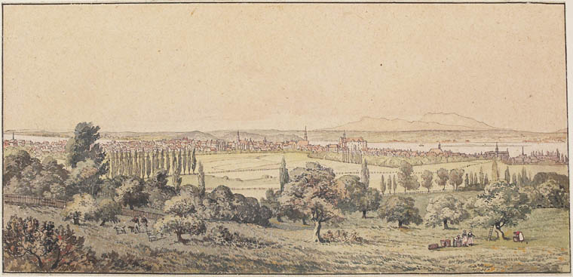
The City of Montreal.
Credit: Library and Archives Canada, Acc. No. R9266-52 Peter Winkworth Collection of Canadiana (1828)

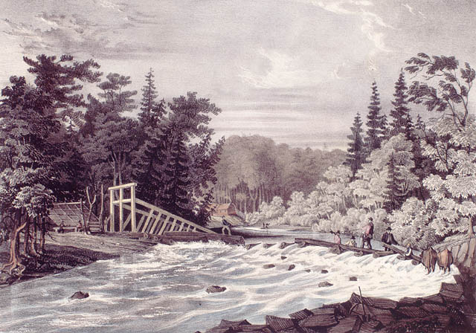
Construction du barrage de moulin, août 1834.
Crédit: Bibliothèque et Archives Canada, no d'acc 1997-91-2 (1836)

