Colors and Metals
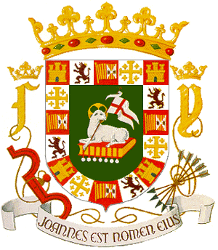
Yellow or gold - Generosity.
Argent, white or silver - Peace and sincerity.
Sable or black - Constancy, sometimes grief.
Azure or blue - Loyalty and truth.
Gules or red - Military fortitude and magnanimity.
Vert or green - Hope, joy and sometimes loyalty in love.
Purpure, purple - Royal majesty, sovereignty and justice.

Nebulee
Heraldic Lines
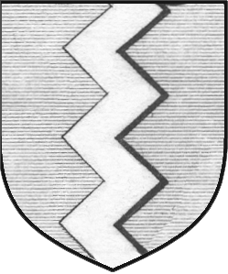
Dancette
Nebulee or Nebuly - The sea or water.
Engrailed and Invected - Earth or land.
Indented - Fire.
Dancette - Water.
Ragulee or Raguly - Difficulties which have been encountered.
Embattled - Fire or the walls of a fortress or town.

Ordinaries
Chief - Dominion and authority.
Cross - Chevron - Protection.
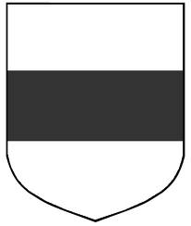
Fess
Fess - Military belt or girdle of honor.
Bar - For "one who sets the bar of conscience, religion and honor against angry passions.
Pale - Military strength and fortitude.
Voiders
Canton - Bearing of honor. When borne charged, it often contains some special symbols
granted by the sovereign in reward for the performance of eminent service.
Quarter - Bearing of honor. Similar to the Canton.
Bend - Defense or protection.
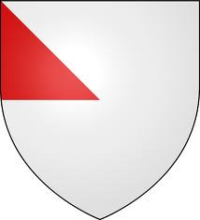
Gyron
Battune Sinister - Marks a royal descent that is barred by illegitimacy from succession to
the throne.
Orle or Tressure - Preservation or protection.
Flasques - Given by a king for virtue and learning, and especially for service in embassage.
Voiders - Given to gentlewomen who have deserved highly.
Bordure or Border - Frequently adopted as a "difference" between relatives bearing the
same arms.
Gyron - Unity.

Common Charges
Lion - Deathless courage.
Tiger - Great fierceness and valor when enraged to combat; one whose resentment will be
dangerous.
Bear - Ferocity in the protection of kindred.
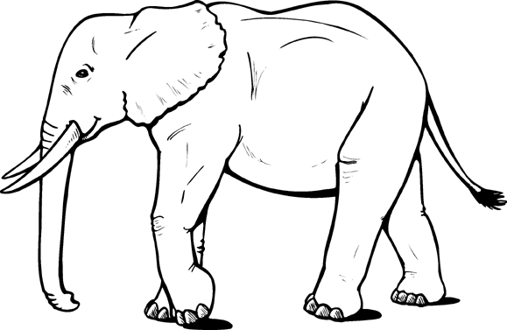
Wolf - Denotes valiant captains that do in the end gain their attempts after long sieges and
hard enterprises. One whom it is dangerous to assail or thwart.
Rhinoceros - Great ferocity.
Elephant - Courage and strength.
Leopard - Valiant and hardy warrior.
Panther - As a lion may be said to signify a brave man, so may a panther a beautiful
woman, which, though fierce, is very tender and loving to her young, and will defend it
with the hazard of her life.
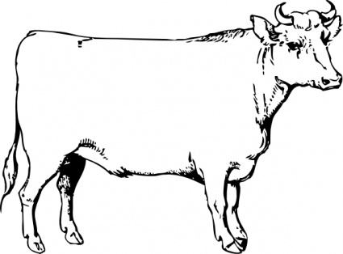
Horse - Readiness for all employments for king and country.
Bull or Ox - Valor and magnanimity.
Goat - Emblem of that martial man who wins a victory by the employment rather of policy
than valor.
Lamb - Gentleness and patience under suffering.
Ram - Authority.
Hares and Rabbits - One who enjoys a peaceable and retired life.
Squirrel - Sylvan retirement being the delight of its bearer.
Hedgehog - Provident provider.
Beaver - Industry and perseverance.
Fox - One who will use all that he may posses of sagacity, wit or wisdom in his own
defense.
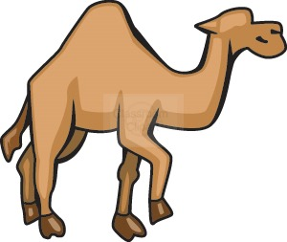
Cat or Cat-A-Mountain - Liberty, vigilance, forecast and courage.
Camel - Docility, patience and indefatigable perseverance.
Bee - Well-governed industry.
Ant - Symbolizes a man of great labor, wisdom and providence.
Spider - Wisdom, labor and providence in all affairs.
Grasshopper - Wisdom and nobility.
Snail - Deliberation and perseverance.
Double Eagle and Eagle - Signifies a man of action, ever more occupied in high and
weighty affairs, and one of lofty spirit, ingenious, speedy in apprehension and judicious in
matters of ambiguity.
Wings - Celebrity, sometimes protection or coverture.
Feathers (usually ostrich) - Willing obedience and serenity.
Falcon or Hawk - One eager or hot in the pursuit of an object much desired.
Hawks or Falcons Bells - One who feared not to signal his approach in either peace or
war.
Owl - One who is vigilant and of acute wit.
Peacock - Beauty and pride of carriage.
Pelican - Devoted and self-sacrificing charity.
Stork - Filial duty, emblem of a grateful man.
Swan - A lover of poetry and harmony.
Goose and Duck - A man of many resources.
Dove - Loving constancy and peace.
Raven - One who, having derived little from his ancestors, has through Providence
become the architect of his own fortunes or one of an enduring constancy of nature.
Crow - Signifies a settled habitation and a quiet life.
Dolphin - Charity and a kind affection towards children.
Tortoise - Invulnerability to attack.
Unicorn - Extreme courage.
Dragon - A most valiant defender of treasure.
Mermaid - Eloquence.
Stag, Hart, Buck and Deer - Policy, Peace and Harmony.
Horns and Antlers - Strength and Fortitude.
Escallop Shell - One who has made long journeys or voyages to far countries, who had
borne considerable naval command or who had gained great victories.
Other Shells - Protection of Providence.
Heart - Charity, sincerity.
Hand - Faith, sincerity and justice.
Red Hand - Usual mark for a baronet if borne on a small escutcheon.
Arm - A laborious and industrious person.
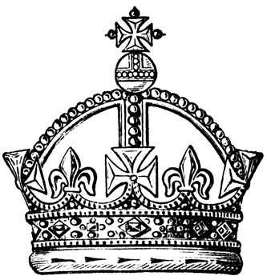
Leg - Strength, stability and expedition.
Shoe - Same as Leg.
Foot - Same as leg.
Crossed Thigh-bones - Mortality.
Eye - Providence in Government.
Crown - Royal or seigniorial authority.
Harp - Contemplation.
Anchor - Succor in extremity and the Christian symbol of hope.
Ship, Lumphiad or Galley - All such symbols would point to some notable expedition by
sea, by which, perhaps, the first bearers had become famous.
Cubes, squares or dice - Constancy, wisdom, verity probity, and equity.
Axe -- Execution of military duty.
Purse - A frank and liberal steward of the blessings that God has bestowed .
Tower or Castle - Grandeur and solidity. Sometimes granted to one who has held one for
his king, or who has captured one by force or stratagem.
Bridge - Signifies a governor or magistrate.
Pillar or Column - Fortitude and constancy.
Snake - Wisdom.
Scaling Ladder - One who was fearless in attacking.
Crosses - Symbolic of some Christian experience or sentiment.
Trestles and stools - Hospitality.
Gold Spur - Dignity of knighthood.
Silver Spur - An esquire.
Sun - Glory and splendor.
Crescent - Signifies one who has been enlightened and honored by the gracious aspect of
his sovereign.
Moon - Serene power over mundane actions.
Fire - Zeal.
Lightning - The effecting of some weighty business with great clarity and force.
Rocks - Safety, refuge and protection.
Trumpet - Ready for the fray.
Cannon, Mortars, Cannon Balls and Grenades - Well bestowed on those who have dared
their terrors in sieges and battles.
Sword - Indicates the bearer to a just and generous pursuit of honor and virtue in warlike
deeds.
Arrows and Arrowheads - Martial readiness.
Spear or Lance - Knightly service and devotion to honor.
Shield - A defender.
Saddles, Stirrups and Spurs - Preparedness for active service.
Horse Shoe - Good luck.
Trunk of a Tree - An object of veneration.
Buckles - Victorious fidelity in authority.
Beacons or Cressets - One who is watchful for the commonwealth or who gave the signal
in time of danger.
Chains - A reward for acceptable or weighty service.
Fusil of Yarn - Negotiation.
Wheel - Fortune.
Chaplets and Wreaths - Granted for special service

