Name: Block:
Comics and Research: Hark! A Vagrant, by Kate Beaton
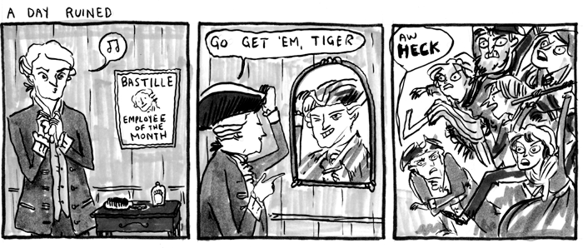
What did the Fall of Bastille (July 14, 1789) actually accomplish?

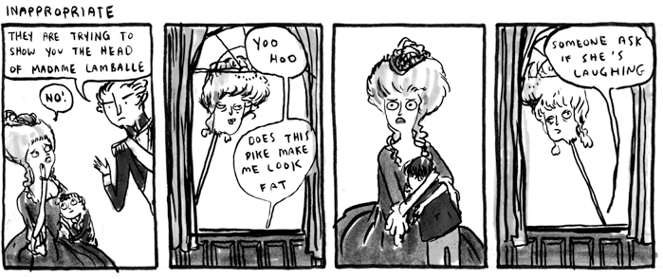
Who was Madame Lamballe? Why was she killed? Was it justified?

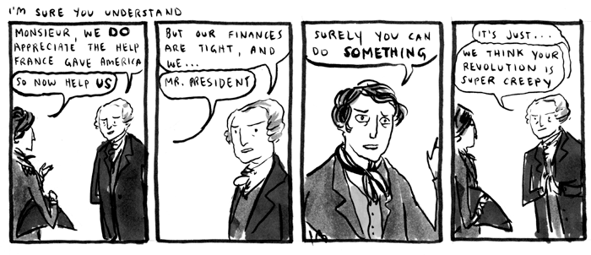
What reasons did Americans have for not supporting the French? Was this opinion shared by all Americans?

