Creating a UTOPIA (a Perfect World)
Utopia: an imagined place or state of things in which everything is perfect

We’ve already done a number of activities in imagining a perfect world in different groups. We are now going to put all of this work onto a poster so that our ideas (and English sentences) are made visible.
Go over the work that you’ve already completed, and choose and edit your work to include on the poster. I will be assessing the poster based on how finished it looks, and if it uses proper English expressions.

Areas to include on your poster:
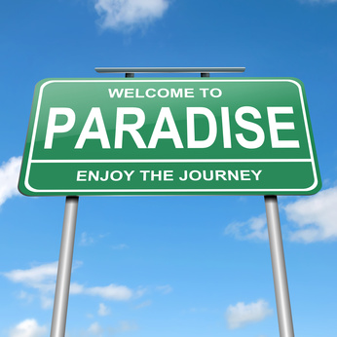
What does your community look like? (include an image)
What jobs does your community have?
What are families like in your community?
How does your community treat the young and the old citizens?
What are some laws or rules that your community would have?
What are some of the punishments for citizens who would break these rules?
What kind of education is available to your community?
What kind of government does your community have?
What are some of your community’s traditions?
What would be your community’s motto?
Anything else that’s interesting!

