

1) Who is the target audience of your speech? Why are you aiming to engage this audience?

2) What is the intention of your speech? (ie: to persuade, to shock, to inspire, etc.)

3) What do you want your audience to feel?

4) What is the tone of your speech? How do you intend to establish this tone? Be specific where appropriate. (ie: diction, oral language, body language, examples, etc.)

5) What persona or character will you mimic (if dramatic monologue)?

4)

## STEP 3: Determine your intention

Circle One: Serious Humorous Dramatic Monologue

## STEP 2: Select a Category for my Speech

My Topic:

What is my MAIN argument?

## STEP 1:

## Choose A Topic

English: Public Speaking Competition

What do I have to say?

## STEP 5: Conclude your speech

What are the 3-5 Main Ideas that you want to include as proof to support your argument?

|  |  |  |  |  |
| --- | --- | --- | --- | --- |
| Idea #1 | Idea #2 | Idea #3 | Idea #4 | Idea #5 |
|  |  |  |  |  |

What specific details will you use to support your main ideas identified above?

|  |  |  |  |  |
| --- | --- | --- | --- | --- |
| Support for  Idea #1 | Support for  Idea #2 | Support for  Idea #3 | Support for  Idea #4 | Support for  Idea #5 |
|  |  |  |  |  |

What will you say to end with a THUD?

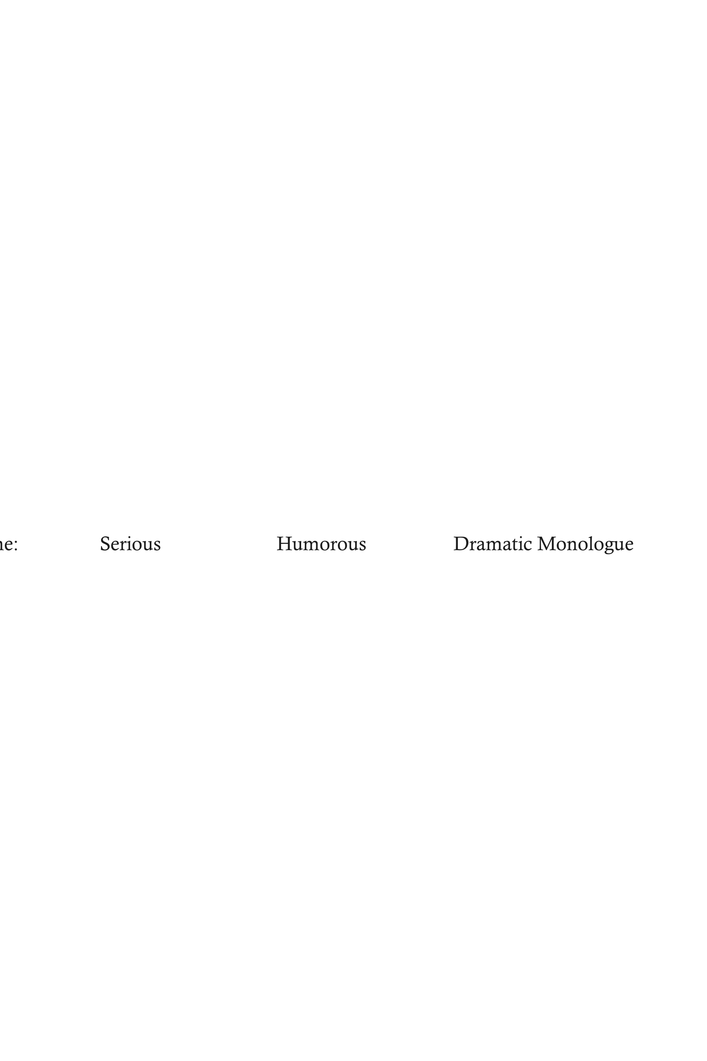

## STEP 4: Identify the MAIN IDEAS you will include in your speech