Name: Block:
Elizabeth I, Piracy, and the Spanish Armada

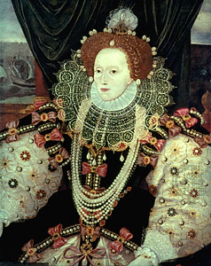
Elizabeth I, bynames The Virgin Queen and Good Queen Bess (born September 7, 1533, Greenwich, near London, England—died March 24, 1603, Richmond, Surrey) queen of England (1558–1603) during a period, often called the Elizabethan Age, when England asserted itself vigorously as a major European power in politics, commerce, and the arts.
Although her small kingdom was threatened by grave internal divisions, Elizabeth’s blend of shrewdness, courage, and majestic self-display inspired ardent expressions of loyalty and helped unify the nation against foreign enemies. The adulation bestowed upon her both in her lifetime and in the ensuing centuries was not altogether a spontaneous effusion. It was the result of a carefully crafted, brilliantly executed campaign in which the queen fashioned herself as the glittering symbol of the nation’s destiny. This political symbolism, common to monarchies, had more substance than usual, for the queen was by no means a mere figurehead. While she did not wield the absolute power of which Renaissance rulers dreamed, she tenaciously upheld her authority to make critical decisions and to set the central policies of both state and church. The latter half of the 16th century in England is justly called the Elizabethan Age: rarely has the collective life of a whole era been given so distinctively personal a stamp.

How is Elizabeth described above?

How does she compare to her father, Henry VII?

Why do you think there was this difference?

Elizabeth’s speech to inspire her troops against the Spanish:
"I have always so behaved myself, that under God, I have placed my chiefest strength and safeguard in the loyal hearts and goodwill of my subjects, and therefore I am come amongst you, as you see, at this time, not for my recreation, but being resolved, in the midst and heat of the battle, to live or die amongst you all, to lay down for my God, and for my Kingdom, and for my People, my honour, and my blood, even in the dust.
I know I have the body of a weak and feeble woman, but I have the heart and stomach of a King, and of a King of England too, and think foul scorn that Parma of Spain, or any Prince of Europe should dare to invade the borders of my realm. I myself will be your general, judge and rewarder of every one of your virtues in the field."
What type of leader was Queen Elizabeth? How do you know?

How is the Queen depicted in the short video clip?

What are some reasons why the Spanish were going to attack Britain?

Why did the Spanish Armada fail?

