Name: Block:
The Enlightenment: The French Philosophes
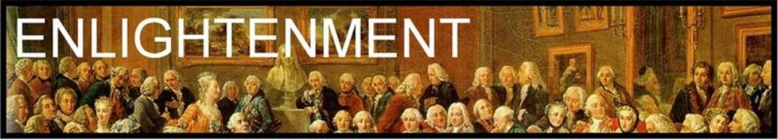
Based on our notes and discussion of the French philosophes, you are going to come up with a discussion between 3 people – 2 MUST be philosophers, and one must be yourself (or someone within the contemporary public eye – maybe Justin Trudeau, etc.).
- You are REQUIRED to write at least one page typed in standard formatting, size 12 font and standard margins, for the conversation. The Conversation can be about anything relevant, as long as it is clear what philosophical beliefs all three people have. You may choose the discussion to be surrounding a contemporary political issue or conflict, or something within your own world (like how to solve the TV drama issue or how to lead the Canucks better).
  - One conversation between 3 people (one page minimum, typed).
- UNDERLINE all parts of the conversation that demonstrate your understanding of each philosopher and their beliefs. For example, underline the part where the philosopher says people are born good.
  - The conversation should be underlined where philosophical opinions are revealed.
- After, you must write a PARAGRAPH explaining how the conversation reveals your knowledge of the two philosophes. This would be your opportunity to include more details and research about where they lived, who they were inspired by, what they helped to change, etc.
  - One paragraph clearly explaining connection between understanding of philosophes, issues, and importance to conversation.
- Include a properly formatted bibliography (in MLA format – use Noodle Tools or Bib Me), citing any extra research that you may have completed outside of class materials.
  - A bibliography.

We’ve already learned about Rousseau, Locke, Voltaire, and Montesquieu.
Want to branch out? Consider the following list of philosophes:
Mary Wollstonecraft
Mary Astell
Benjamin Franklin
David Hume
Denis Diderot
Claude Adrien Helvetius
Jean le Rond d’Alembert
Immanuel Kant
Cesare Beccaria
Marquis de Condorcet
Francesco Mario Pagano

Brainstorm Space:
Possible philosophes | Guiding principles and beliefs | Possible conversation topics | Philosophe’s stance on topic?

We will complete a peer edit and finalize a good copy next class – you must be prepared with your conversation AND paragraph explanation.

