SS9: French Revolution Review Sheet

Take time to review the following people, places, and concepts to prepare for our next QUEST! Look back through your notes, handouts, and on our website to view slides and other relevant materials.

PEOPLE
John Locke  Jean-Jacques Rousseau  Charles-Louise Montesquieu  Francois Voltaire  Louis XIV (14)  Louis XVI (16)  Marie Antoinette | Jean-Paul Marat  Madame Roland  Jacques Danton  Maximillien Robespierre  Napoleon Bonaparte  Madame Lamballe

GROUPS
Philosophes  Girondins (Girondists)  Jacobins  Sans-Culottes  The National Assembly | The Legislative Assembly  The Estates General  (First, Second, and Third)  The National Guard

PLACES
Paris  Versaille | Bastille  the Tennis Court

CONCEPTS
The Enlightenment  The Declaration of the Rights of Man and Citizen  the American Revolution (and English Civil War)  changing fashion  the tricolore  the reign of terror | the law of suspects  French Independence Day  "Liberty, Equality, Fraternity"  Tithe  republic/constitutional monarchy/absolute monarchy  divine right

KEY QUESTIONS TO CONSIDER:
What was life like for each of the three estates?

What are some reasons for political and social unrest?

How did Enlightenment philosophes affect change? To what degree?

What are some reasons why people disliked the monarchy?

What events led to the Reign of Terror, and the fall of power of the monarchy?

Is state violence justified? To what degree?

Was the revolution successful? Why or why not?

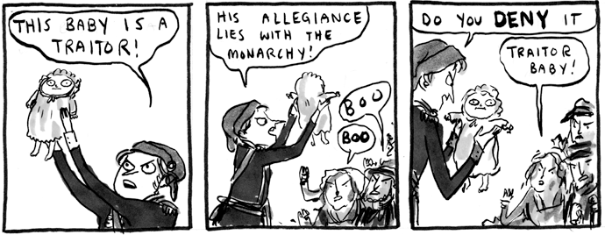

Kate Beaton, Hark a Vagrant

