- Arrival at the Camp

When the victims arrived to the extermination camps in overcrowded trains, they were pushed out onto the arrival ramp. Here, German SS-men and brutal Ukrainian guards forced them to hand over their belongings and their clothes. Most of the victims had been told that they were merely to be moved to the east for new jobs and living places, and most of them had brought their favourite belongings.

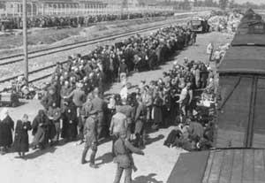
Selection at the arrival ramp in Auschwitz-Birkenau. The deported Jews were either selected for work or for immediate gassing. In the background: a group of people on their way towards gas chamber no. II.

In the extermination camps, men were separated from women upon arrival. Everybody had their
hair shaved and all of their possessions and clothing were taken away. They were given a striped uniform to wear in the camp. All prisoners were given a number which was tattooed onto their arms.
The SS chose those able to work for the work camps. Those who could not work – the old, women and children – were immediately sent to the gas chambers or shot in the "camp hospital". Even those able to work eventually ended up in the gas chamber, or were the victims of random shootings within a few months when they had been worn out by the tough work. Those able to work did difficult jobs like helping to carry the bodies to the crematoria or search the bodies for valuables.
The bodies were looted of gold (from the teeth), before being thrown into large mass graves. When the Soviet armies started to advance through Poland, the Nazis tried to hide their terrible crime and the bodies were burned – either in mass graves or in the crematoria.
There are few examples of uprisings in the extermination camps. In Sobibor and Treblinka prisoners tried to rebel in 1943, and the same was tried in Auschwitz in 1944. Only a very few managed to escape.

- Life in Auschwitz

Auschwitz Concentration Camp opened in June 1940. By 1942, the camp had 28 two-story buildings, the most of which were used to hold prisoners. In each building there were two large rooms upstairs and a number of smaller rooms downstairs. The buildings were made to hold about 700 prisoners each, but in reality they housed up to 1,200.

During the first several months, the prisoners’ rooms had neither beds nor any other furniture. Prisoners slept on straw-stuffed mattresses laid on the floor. When they woke up, they piled the mattresses in a corner of the room. The rooms were so overcrowded that prisoners could sleep only on their sides, in three rows. Three-level bunk beds began being put in the rooms in February 1941. There was always more than one person sleeping on each bunk.

Each building had bathrooms with 22 toilets, urinals, and long sinks with 42 taps. The fact that prisoners from the upstairs and downstairs had to use a single bathroom meant that people had to wait a long time to use it.

Prisoners had three meals per day. In the morning, they received only half a liter of “coffee” (which was actually boiled water with a coffee substitute added) or “tea” (a mix of different plants). These drinks were very bitter. The noon meal was about a liter of soup. The main ingredients of the soup were potatoes, rutabaga, and small amounts of groats, rye flour, and Avo food extract. The soup was gross, and new prisoners were often unable to eat it because it was so disgusting. Supper consisted of about 300 grams of black bread, served with about 25 grams of sausage, or margarine, or a tablespoon of marmalade or cheese. The bread served in the evening was supposed to cover the needs of the following morning as well, although the famished prisoners usually consumed the whole portion at once.

The combination of not enough food and a lot of hard work meant that people’s bodies stopped working properly. This led to emaciation and starvation sickness, the cause of a significant number of deaths in the camp. Emaciation is when a person becomes extremely thin and their body has no fat left.
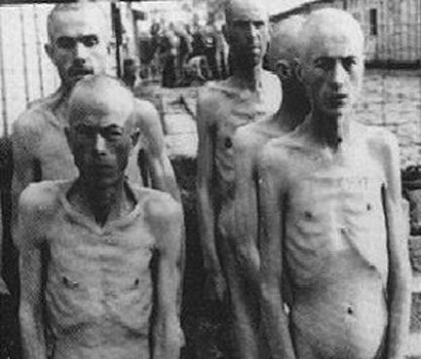
Prisoners in Auschwitz
- Working in Auschwitz

In the summer, the prisoners started working at 4:30 in the morning. In the winter, they started working at 5:30am. The prisoners got up at the sound of a gong and carefully tidied their living quarters. Next, they attempted to wash and relieve themselves before drinking their “coffee” or “tea.” At the sound of a second gong, they ran outside to the roll-call square, where they stood in lines. The prisoners were counted during roll call. If the numbers did not add up, everyone had to stand and wait while the guards figured it out. Finally, the prisoners were ordered to get into their work groups. After February 1944, the guards got rid of the roll-call because they thought it took up too much time. From that point on, prisoners went right to their work groups when the second gong rang.

Prisoners did many different kinds of work inside and outside the camp borders. Beginning at the end of March 1942, prisoners had to work at least 11 hours. They worked longer in the summer and a little shorter in the winter. The break for lunch lasted from 12 until 1 o’clock. Depending on the time of year, prisoners might get an extra hour or only get half an hour. In the early days, a roll call followed lunch, but this was ended eventually.

Prisoners returned to the camp under SS escort before nightfall. They often carried the bodies of those who had died or been killed while laboring. The evening roll call began at 7 o’clock and, as in the morning, could be longer if number of prisoners was off. After roll call, the prisoners received their evening bread. They had free time after the evening meal. Prisoners waited their turn for the washrooms and toilets until the first gong rang, meaning everyone had to return to their rooms. They could also receive mail or visit acquaintances in other blocks. The second gong, at 9 o’clock, meant everyone must be silent and sleep.

Prisoners did not have to work at all on Sundays and holidays, which they spent tidying up their quarters, mending or washing their clothes, or shaving and having their hair cut. They could also attend concerts by the camp orchestra and, every other week, send official letters to their families.

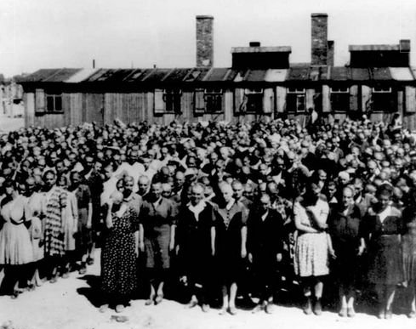
Roll call in Auschwitz, 1944.
- Experiments

During World War II, some German doctors did painful and often deadly experiments on thousands of concentration camp prisoners without their permission.

There were three kinds of experiments. The first kind was to help make the army better. In Dachau, physicians from the German air force did high-altitude experiments. They wanted to find how high was safe for people to parachute out of an airplane. Scientists in Dachau also did freezing experiments using prisoners to find out how to rewarm the human body. Some people were dunked in freezing water for three hours and then the doctors would try different ways of stopping the person from dying from the cold. They also used prisoners to try and find out how to make water from the ocean drinkable.

The second kinds of experiments were for making and testing medicine and treatments for injuries and illnesses which could happen to German soldiers. At the German concentration camps of Sachsenhausen, Dachau, Natzweiler, Buchenwald, and Neuengamme, scientists tested immunizations to stop contagious diseases from spreading, such as malaria, typhus, tuberculosis, typhoid fever, yellow fever, and infectious hepatitis. The Ravensbrueck camp was the site of bone-grafting experiments. Bone grafting is surgery to try and replace missing bone when it gets broken. At Natzweiler and Sachsenhausen, prisoners were forced to breathe in mustard gas in order to test possible antidotes.

The third kind of medical experimentations were to try and prove that the Nazi’s were the superior race. The most infamous were the experiments of Josef Mengele at Auschwitz. Mengele conducted medical experiments on twins. Experiments on twin children in concentration camps were created to show the similarities and differences in twins, as well as to see if the human body can be unnaturally changed. Mengele did experiments on over 1,500 sets of imprisoned twins. Less than 200 people lived after his experiments. Mengele organized the testing of genetics in twins. He did things like inject different chemicals into the eyes of the twins to see if it would change their colors, and literally sewing the twins together to try and create conjoined twins.

Mengele also directed blood experiments on Roma (Gypsies), as did Werner Fischer at Sachsenhausen, in order to determine how different "races" survived different kinds of contagious diseases. The research of August Hirt at Strasbourg University also tried to prove "Jewish racial inferiority."

Other gruesome experiments meant to further Nazi racial goals were a series of sterilization experiments, mostly done at Auschwitz and Ravensbrueck. There, scientists tried to find an easy way to make sure Jews, Roma, and other groups Nazi leaders hated, could no longer have children.

- Extermination Methods

The Nazis and their helpers used the most terrible methods of murdering Jews, gypsies and other “undesirable” population groups. In the attempt to carry out the Final Solution as well as possible, different methods of mass murder were tested. The Nazis began by using mass shootings, then used gassing trucks (in the first extermination camp, Chelmno) and ended up by building large facilities of mass destruction as in Auschwitz-Birkenau, where the very deadly Zyklon B gas was used.
One of the most effective killing methods was by forcing Jews into gas chambers, where they were gassed to death using exhaust fumes or Zyklon B.
In five of the six extermination camps, gas chambers were built with the single purpose of killing Jews, gypsies and other ’undesirables’. In the Chelmno extermination camp gassing trucks were used for this horrible activity.
The process of killing the victims in gas chambers was the following: the victims were forced into the gas chamber, the door was closed and either exhaust fumes or Zyklon B-gas flowed into the room. In the extermination camps at Belzec, Sobibor and Treblinka exhaust fumes were used, while Zyklon B was used in Majdanek and Auschwitz-Birkenau.
Gas chambers were sometimes disguised as shower rooms so that prisoners would go in willingly. Once the gas chamber was full of adults, children were sometimes pushed in above the adults’ heads to kill as many people as possible. At least 3 million Jews were killed in the extermination camps that had been constructed with the single purpose of killing Jews as effectively, quickly and secretly as possible.

Holocaust Worksheet: Inside the Death Camps

Read the article for your section and answer the questions with your group. You will all become experts on your section. Make sure you write down the answers for each question so you do not forget. The groups will then be split up and we will make new groups with one person from each of the sections (every group will have one person who was in Group A, one person from Group B, etc.). Everybody will take a turn explaining the answers to their questions and any other interesting information their group read in the article.

Group A:
- Where did many prisoners think they were going before they arrived at Auschwitz?
- What happened to the men and women when they got there?
- How did the Nazis label the prisoners?
- What did the Nazis do with the dead bodies?
- What other information does your group think is interesting?

Group B:
- Where did everybody in the camp sleep? What were their beds like?
- How many people lived in each building?
- What made using the bathroom difficult for the prisoners?
- How many meals did the prisoners get every day?
- What happened to people when they did not have enough food?
- What other information does your group think is interesting?

Group C:
- How early did the prisoners have to wake up in the morning?
- How long did the prisoners usually have to work?
- What did prisoners usually have to bring home with them from work?
- Did the prisoners get days off? What days did they not have to work?
- What other information does your group think is interesting?

Group D:
- How many kinds of experiments did the Nazis do?
- What were the different kinds of experiments?
- What were the twins experiments? What kinds of things did Mengele do?
- How many people lived after Mengele experimented on them?
- What other information does your group think is interesting?

Group E:
- What were the three ways the Nazis tried to finish the Final Solution?
- What was the name of the common gas used by the Nazis?
- What kind of gas did they use at Auschwitz?
- What other information does your group think is interesting?

