Name: Block:
Immigrants in Early Canada
Your job is to create a document, presentation, or media project that explores and explains the experience of immigrants in early Canada.
You will have to focus on one immigrant group, but you will have to show in your project that you understand what was happening to the other immigrant groups – including Native peoples.

Immigrant Groups:
Americans
British
Irish
African Americans
(Native People)

Project Options:
A newspaper report, journal entry, or short story documenting their experiences
A presentation to give to the class
A history video clip or re-enactment of one experience
A song inspired by slavery songs
Free choice (approval from me first)

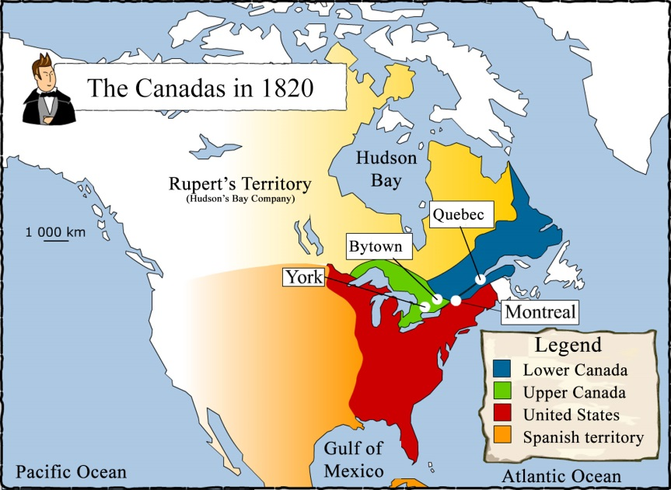
You will be assessed based on the historical accuracy, attention to detail, and amount of presence (if presenting) you put into this project.

