Name: Block:
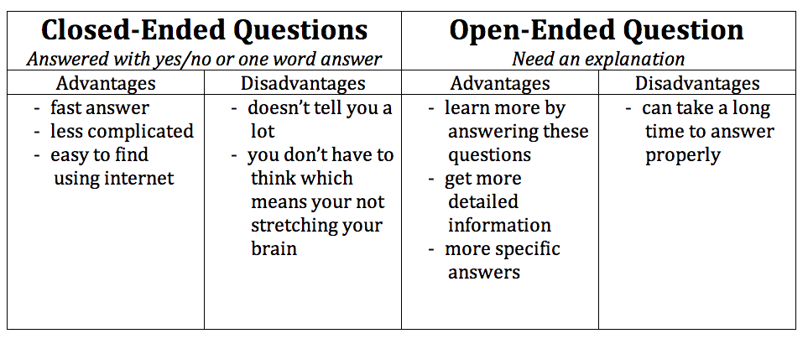
Write if the following questions are open-ended (O-E) or closed-ended (C-E) questions.

Do you like the colour blue?
Is pizza your favourite food? ​
Which athlete do you prefer?
​Do you like school?
​Are you going on holiday over Christmas? ​
Do you live more than 10 minutes away? ​
Have you ever been to Spain? ​
Why don’t you like using a computer? ​
Were you in school yesterday? ​
Where is your favourite place to visit?
​​Do you like rock music? ​
Which is your favourite band?

Come up with 5 open-ended and 5 closed-ended questions that would help you to really get to know someone.

Open-Ended Questions | Closed-Ended Questions

