Name: Block:
Current Event Assignment
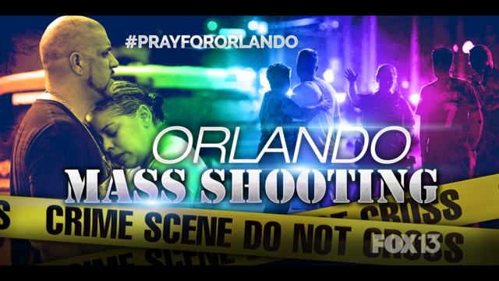
From http://www.fox25boston.com/news/orlando-nightclub-shooting-is-the-deadliest-mass-shooting-in-american-history/338436623
Discuss: What do you know about this event? How many different factors are involved? How many different interest groups?

In order to practice for our first current event assignment, try to find out as much as you can about the information surrounding this event, considering as many angles as you can. As you research, fill out the chart below:

Background information:  Consider Who, What, When,  Why, Where, How Come? | What makes this image important to the world? To  Canada? | Are there any dissenting opinions concerning this event?
A question you could ask other students that sparks discussion:

