Komagata Maru: Beyond An Apology
Naveen Girn, The Huffington Post, Posted: 05/18/2016 12:44 pm EDT Updated: 05/18/2016 12:59 pm EDT
Is an historical apology meaningless if those who were wronged are no longer around to receive it? In the case of the Komagata Maru, the passengers, politicians, immigration officials, and crew have all passed away. The people who raised thousands of dollars to pay for the passengers' legal fees and the people who gathered at meetings in 1914 to support Asian exclusion have also passed away. The Komagata Maru ship itself was sold off for spare parts decades ago and no physical marker of it remains.
Yet, what does remain is the injustice. What lives on is the knowledge that Canada passed laws that were racist and sought to legitimize discrimination under the guise of legal process and parliamentary procedure. We did something wrong -- and it was state sanctioned.
Even if a single person from that time does not exist, that doesn't change the fact that so many of us are directly affected by this historic injustice.
What is the author’s opinion?
For those who have strived for an apology, Wednesday's announcement will deservedly be the fulfillment of years of hard work. But I'm concerned with an element that was present in Prime Minister Stephen Harper's original apology: "An apology to those directly affected".
While the descendants of Komagata Maru passengers have a direct biological connection to the events of 1914, that's a simplistic and nominal understanding of what it means. Speaking historically, and as a reflection on our development as a nation, 'directly affected" includes all of us.
Who was Stephen Harper’s apology directed to?
We're affected when our histories are not included in school textbooks. We're affected when 4th and 5th generation South Asians are questioned of where they are really from, or stopped for "extra security checks" when flying. We're all affected when comments to stories such as this elicit anonymous racist trolls. When the defining story of your community is an event that happened over 100 years ago, we're all directly affected when other stories are not given the space and prominence to be heard.
All Canadians were 'directly affected' when the Komagata Maru was turned away.
My second concern is that apologies have a way of indicating closure. While acknowledging a historical wrong is personally resonant with many descendants of Komagata Maru passengers, we must be careful that other conversations are not similarly "closed". We can have an apology and still critique the government for failed immigration policies towards asylum seekers and temporary foreign workers.
What does it mean to close conversation?
We can accept the apology and still be on guard against racial stereotyping of immigrant and migrant communities similar to those narratives projected onto Komagata Maru passengers. And yes, we can accept the apology and still call out systemic racism, discrimination, and white privilege. It is our duty to do so. Because if we agree with the values of security, freedom, and opportunity that motivated the Komagata Maru passengers -- and other migrant communities-to come to Canada, and if the state is failing to meet those ideals, then it must be held to account.
So instead of closure, the Komagata Maru apology demands more of us all. We must demonstrate that our motivation was not a particular story, or simply one community's historical injustice. We have to continue finding and helping allies who are engaged with similar projects of redress. We must also understand that this idea called Canada requires constant exploration and opening up of our collective past. It also requires a movement towards marginalized perspectives and towards stories of empathy and understanding.
Now that the Komagata Maru apology will permanently be entered into the Parliamentary record of our nation, the burden is on all of us to choose how we integrate this event into our shared national memory.
What does the author want?
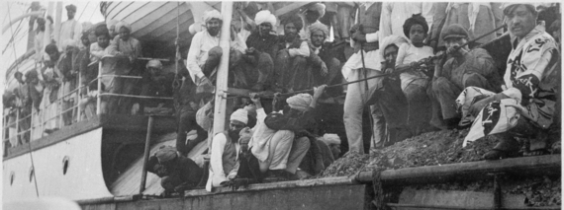

Does Justin Trudeau’s apology fulfil the desires of this author, in terms of a proper apology? Why or why not? Explain!

