Name: Block:
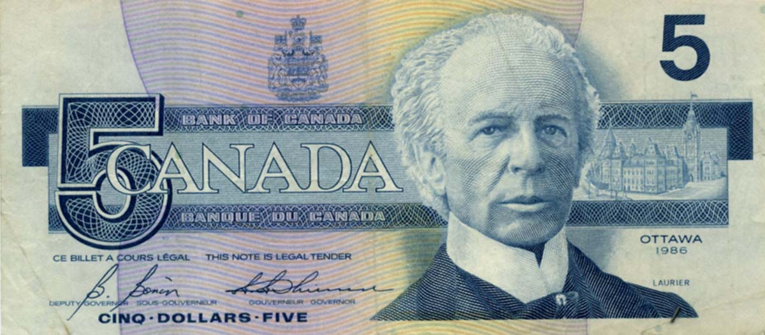
Wilfrid Laurier: does he deserve to be on the $5 bill?

Wilfrid Laurier was Canada’s first French-Canadian Prime Minister. He was elected in 1896 and served until 1911. Laurier wanted to promote national unity in Canada and to protect Canada’s interests in the world. However, since the Northwest Uprising of 1885 and the execution of Louis Riel, tensions between English and French Canadians had grown. As a French Canadian, Laurier had to be careful when dealing with issues of language and religion. French and English Canadians also disagreed about Canada’s relations with Britain and its empire. Yet despite these challenges, Laurier had confidence in his country’s future and was convinced that “the 20th century belonged to Canada”

According to the video, what is Wilfrid Laurier known for?

Quotes: Sir Wilfrid Laurier
“For us, sons of France, political sentiment is a passion; while, for the Englishmen, politics are a question of business." - speech in Montreal, [[May, 19, 1884] (translation)
"Below the island of Montreal the water that comes from the north from Ottawa unites with the waters that come from the western lakes, but uniting they do not mix. There they run parallel, separate, distinguishable, and yet are one stream, flowing within the same banks, the mighty St. Lawrence, and rolling on toward the sea bearing the commerce of a nation upon its bosom - a perfect image of our nation." - speech at Toronto, December 10, 1886
"Confederation is a compact, made originally by four provinces but adhered to by all the nine provinces who have entered it, and I submit to the judgment of this house and to the best consideration of its members, that this compact should not be lightly altered." - House of Commons, Debates, 1907
Based on the quotes above, what sort of Prime Minister do you think Wilfrid Laurier was? Why?

Examples of Policy: The Manitoba Schools Question
When Manitoba joined Canada in 1870, equal rights were given to English-language Protestant schools and English-language Roman Catholic schools under the Manitoba Act. However, during the 1880s, the arrival of English-speaking immigrants created an English-speaking majority in the province. Pressure was placed on the government to review its language laws. The result was the Manitoba Schools Act, which removed government support from Roman Catholic schools. Francophones across Canada were outraged.
The Liberals had won the support of Quebec voters on a promise to protect the French language and Roman Catholic rights. Laurier believed in solving problems by compromise, so with Manitoba’s premier, Thomas Greenway, Laurier worked out the following solution:
- Upon request, French instruction would be allowed in any school that had a minimum of 10 French-speaking students.
- There was to be no government funding for a Catholic school board.
- Catholic religious instruction would be allowed for a half-hour at the end of the school day.
Laurier’s compromise left French Catholics feeling that they had given up far more than English speaking Manitobans. For Laurier, it was a lesson in how difficult it was to govern Canada.

Based on what you know of Laurier so far, does he deserve to be on the $5 bill? Why?

