Name: Block:
The Manitoba Act: 1870
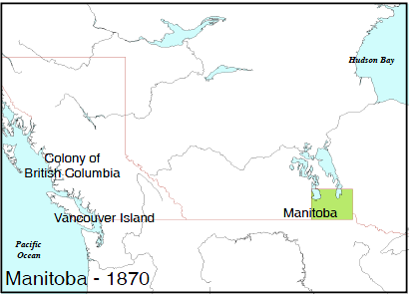
Following the Red River Rebellion and Riel: the Metis made up the majority of population of Manitoba
1.4 million acres of land were reserved for Metis farmland
French and English official languages
Two education systems: Protestant and Roman Catholic
BUT: John A. Macdonald sent in ‘troops’ to keep peace.
“These impulsive Metis have got spoilt by the emeute [uprising] and must be kept down by a strong hand until they are swamped by the influx of settlers”
Answer below: What do you think happens to the Metis? What is JAM’s plan?

Many Metis died from being beaten by these troops
Metis had to have a scrip, a piece of paper similar to money, that showed that they owned land (title) – they needed money scrip, which had a value of $160 (equal to a quarter section of land), and land scrip
When land speculators (write definition: ) came, they bullied, tricked, and threatened the Metis for their scrip because the Metis didn’t understand this sort of ownership title
The speculators bought land for cheaper than was valued, and could use these new lands as collateral (write definition: ) to get more loans
Answer below: What do you think happened to the Metis population in Manitoba?
