Name: Block:
Mapping North America!
Reproduce the map on page 296, indicating the territorial lines established after the Treaty of Paris, 1763. Include a key indicating territory for Britain, Spain, France, French fishing rights, Russia, and unclaimed territory (Aboriginal).
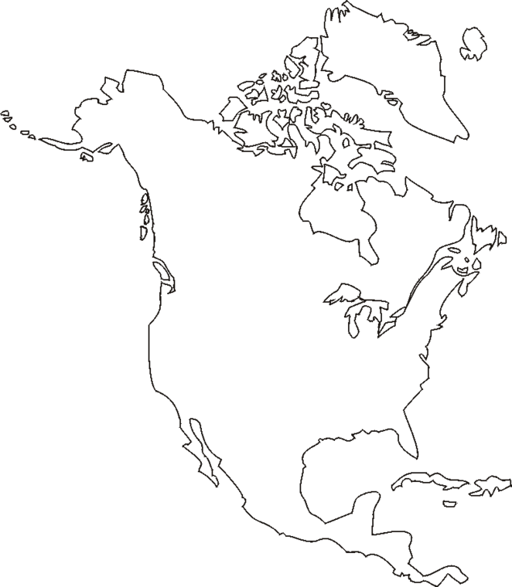
Now, reproduce the map on pages 298 and 299, showing the territorial lines after the Royal Proclamation (1763) from page 299; locate and label the territory of the Cree, Montaignais, Algonkian, Mi’Kmag, Ottawa, Iroquois, Huron, Ojibwa, Sioux, and Apache (from 298), indicating which groups had land reserved after the Proclamation.

