Name: Block:
Mercantilism!
Mercantilism, also called "commercialism,” is a system in which a country attempts to amass wealth through trade with other countries, exporting more than it imports and increasing stores of gold and precious metals. It is often considered an outdated system.
The noun mercantilism came from the Latin mercāns, or "buyer." It was a system that encouraged the idea of government trade regulation to gain wealth, a move away from agriculture system as an economic base. Although largely rejected today, it was the main school of economic thought from the 15th through the 18th Centuries, and was the push behind much of the exploration and colonization of other lands — and many of the wars — that happened during that time.
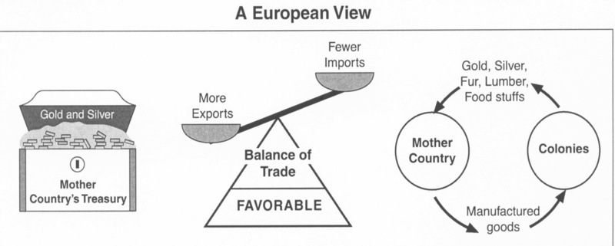
Why would Britain pursue mercantilism? What benefits does it have? What would Britain need in order to be successful?

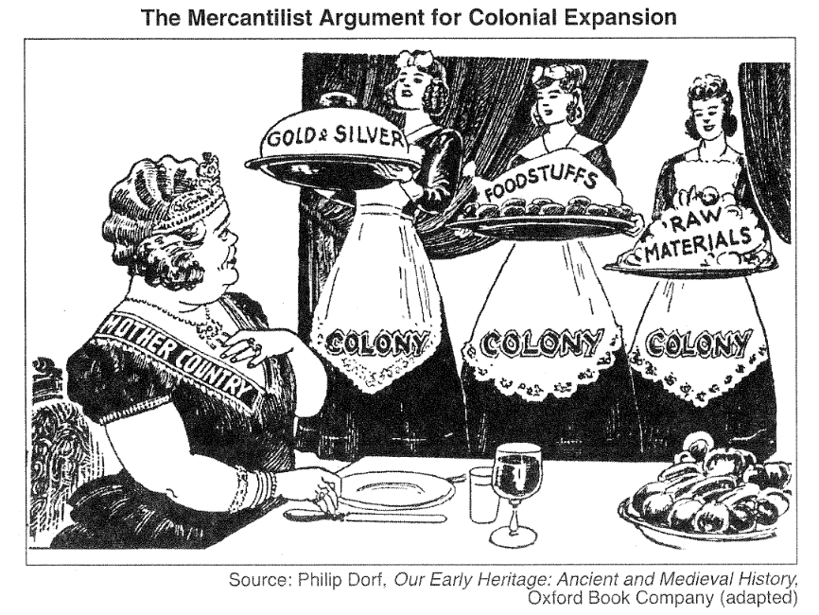
Look at the comic above. Who are the characters in this cartoon? Who is the woman on the right supposed to represent? Whose view point is this taken from (is it favourable to the woman on the left or not?)? What do you think is the opinion of the cartoonist?

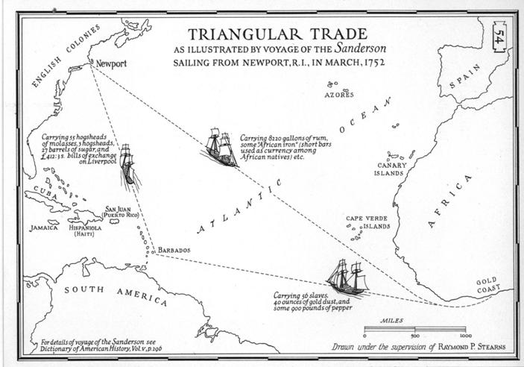
The Triangular Trade is a multilateral system of trading in which a country pays for its imports from one country by its exports to another.
It is used to refer to the trade in the eighteenth and nineteenth centuries that involved shipping goods from Britain to West Africa to be exchanged for slaves, these slaves being shipped to the West Indies and exchanged for sugar, rum, and other commodities, which were in turn shipped back to Britain.
What is the difference between Triangular Trade and Mercantilism?

How would Triangular Trade affect Canadians?

Define the following terms
Import:
Export:
Goods:
Markets:
Colony:

If you were a colonist, mercantilism often resulted in unfair trade conditions – by using taxation and trade barriers. To get around the unfair tactics of mercantilism, some colonies turned to smuggling goods. While illegal, smuggling was often the only way merchants in the colonies made money.
What do you think was worse, British mercantilism or colonial smuggling? Why?

