War Veterans, 1816
“Barracks at Queenston and camp on the mountain” (June or July 1793), from National Archives of Canada / C-013919
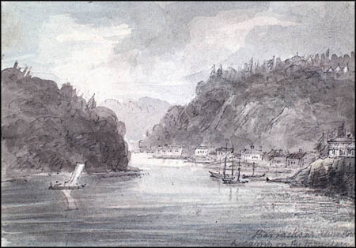
As a reward for their service, the British Crown gave its war veterans stationed in Canada after the War of 1812 free land grants. These veterans usually received land between the Ottawa and St. Lawrence Rivers in Upper Canada, and the size of the plots they received depended on their rank. All were given eight months worth of food rations, so they'd have enough to eat until they were able to set up sustainable farms.
Out-of-work British soldiers and naval officers who had fought during the Napoleonic Wars in Europe also were allowed to settle here as well. The British government aggressively encouraged these veterans to settle its North American colonies, as many of them would otherwise be returning to lives of utter poverty in Britain.
Britain benefited enormously by sending these veterans to British North America:
- It allowed Britain to sidestep a costly social problem (i.e. having to provide money to support thousands of soldiers stricken with poverty and disease in the United Kingdom).
- The British colonies would become full of upstanding military veterans who would be more likely to take active leadership roles in burgeoning communities.
The policy of giving free land to soldiers and sailors would last until 1833. A deadly outbreak of cholera in Britain caused the discontinuation of this policy.

Why were war veterans given land? Where did they come from originally? What affect did this have?

The Canada Company, 1825 - 1953
The Canada Company was a private firm, the brainchild of John Galt, whose sole purpose was to sell land to settlers. The formation of this company marked a major shift in land granting policy. Now, private companies, not the government, would be in charge of land administration in Upper Canada.
The Company drew the ire of Reformers, however. They felt the Company:
- was poorly managed;
- treated farmers and lower class settlers unfairly;
- was too closely linked to the Tory government and its wealthy friends.
This situation helped fuel the mass anti-government sentiment that led to the 1837 Rebellion in Upper Canada.
The Canada Company's problems finally died down in the early 1840s. Management and administrative changes were made to make the business run in a smoother and fairer manner.
The company ran this way, more or less, until 1951, when it announced it was selling off all its lands and going out of business. It finally closed down in 1953.
What was the Canada Company? Why were people unhappy with it?

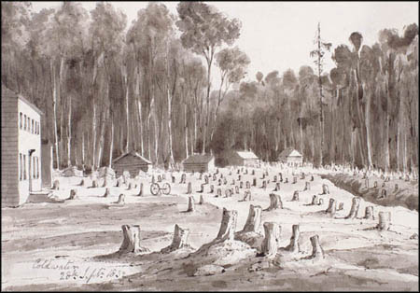
“The Settlement of Coldwater, Upper Canada” (1832), National Archives of Canada / C-115022

Petworth Emigration, 1832
Under these arrangements an excellent opportunity is afforded to respectable unmarried females, who may wish to join any relations or friends, already settled in Upper Canada; as they could be placed under the immediate protection of the superintendent and his wife.
*List of Necessaries for Emigrants to Upper Canada
Families should take their | Single Men must have
Bedding  Blankets  Sheets, &c.  Pewter plates, or wooden treuchers  Knives and forks, and spoons  Metal cups and mugs  Tea kettles, and saucepans  Working tools, of all descriptions.  (A large tin can, or watering pot would be useful.) | A bed or mattress  A metal plate, or wooden trencher  Some kind of metal cup or mug  Knife, fork, and spoon  All, or any of which, may be procured at Portsmouth, if the parties arrive there unprovided.
* See Capt. Hale's Instructions, p. 72
Besides various other portable articles in domestic use (especially of metal) according as families may be provided. A cask, not exceeding the size of a hogshead, or 60 gallons, affords an excellent and dry case, for packing such articles as are not likely to be wanted 'till the end of the voyage. All packages should be marked with the owners name, in large letters. Five hundred weight of luggage is allowed to be taken by each individual, above 14 years of age.
The following is the lowest outfit, recommended to Parishes for their Laborers, of course, including such articles as they already possess.
A fur cap  A warm great coat  A flushing jacket & trowsers[sic]  A duck frock and trowsers  A canvas frock and two pairs of trowsers | Two Jersey frocks  Four shirts  Four pairs of stockings  Three pairs of shoes  A bible and prayer book
Women in the same proportion, especially a warm cloak.
All the above may be purchased at Petworth.
It is also a matter of great importance, that emigrants should take with them a good character, (if they should have the happiness to possess one,) fairly written, and well attested; also, copies of marriage or baptismal registers, or any other certificates or papers likely to be useful; the whole to be inclosed in a small tin case.
What are some important supplies for new immigrants? What sort of people would they have to be?

The Great Migration Video

What is the condition of Native people?

What are the two main religious groups from European immigrants?

What does a typical family look like?

What is one new thing you learned about The Coffin Ships?

What does ‘quarantine’ mean?

Who was Harriet Tubman?

How did Canadians feel about escaping African Americans?

What’s one new thing you learned about the Underground Railroad?

