Name: Block:
Napoleon and Europe
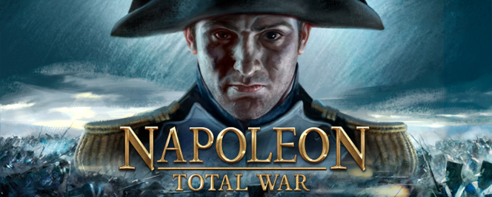
Napoleon and Britain
After Napoleon becomes (1804), and before, he expands his Empire
Britain was one his greatest (navy)
- Britain would give money and supplies to any who would fight Napoleon
- 1805, Napoleon
- Ships spotted and captured by
FAILS: Napoleon never can
The Continental System
SO, any country in Napoleon’s Empire can’t trade with Britain (or its colonies)
- Including allowing British to dock in ports
- The in price leads to increased smuggling ( )
Napoleon could never enforce the Continental System
  - British still goods
  - European ships forced to stay in
  - British on trade to Europe (i.e. America) – which led to
Conquering Europe
Napoleon realized he’d need to continue his (military, political, economic control)
- Won at battles of (armies of Austria, Russia, and Prussia)
1807, signed the with enemies, creating a significant empire
Napoleon, the General
Read pages 108-109 in Crossroads
Describe Napoleon as a general; what made him successful?

The New Map of Europe
After the treaty, Europe was divided, and many members of Napoleon’s were made monarchs:
- Old Holy Roman Empire was demolished
- Parts of Germany made into the new
- Northern Italy was made into a single state (controlled by France)
- Much of Poland became the of Warsaw
- Russia, Austria, and Prussia became allies, but kept their own rulers
- ONLY remained independent in Europe
The Revolution, continued
Napoleon spread ideas of the French Revolution, ending
- Governments and legal systems (based on French model)
- Abolished
- Abolished inherited privileges of aristocrats
- Spread
- Encouraged tolerance

