Name: Block:
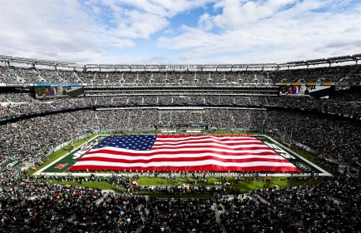
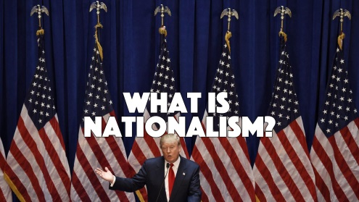
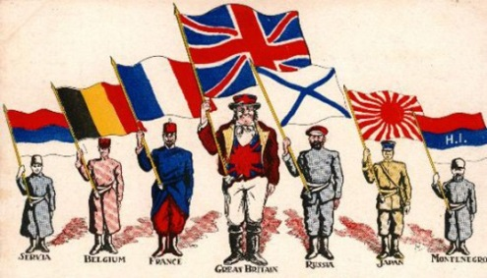
Nationalism and Patriotism

Write a definition for Nationalism:

Write a definition for Patriotism:

How are they different?

Video Questions: America, Europe, and Nationalism
Why is there a difference between America and Europe?

What is an interesting thing you learned?

What is the video’s thesis (argument)? Is Nationalism bad? What do you think?

Crossroads Textbook, pages 111-113
- How did other nations feel about French ideals? About Nationalism?

- What’s an issue with extreme nationalism? Give an example.

- What caused issues for Napoleon’s rule over Spain?

- How did the Spanish fight? What contributed to their success?

- Who was the “Maid of Saragossa”?

