Name: Block:
The Giver: Newspaper Announcement
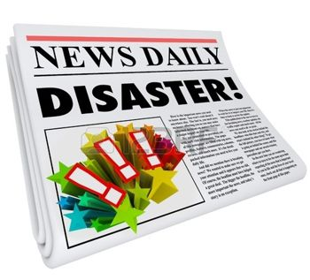
Jonas has just run away with Gabriel from his community! How do you think the community would react? What would a newspaper look like after Jonas leave? Would it discuss how Jonas left? Or would it pretend that nothing bad happened? What else would be on the front page?

Create the front page of a newspaper for Jonas’s community. Think about the significance of the media in a society such as Jonas’s when creating the content and style of your newspaper features. You should include several components:
- Editorial (an opinion piece by someone important)
- At least one visual/picture
- A news story
- An announcement
- A title for the newspaper
- Formatting following a usual newspaper

Please look at examples of newspapers for inspiration!

