Name: Block:
Closing the “Open-Door” Policy
Canadians began to dislike Clifford Sifton’s ‘open-door’ policy to immigration. Reasons why:
Labour Organizations:

British-Canadians:

French-Canadians:

(Business People):

In 1905 Frank Oliver replaced Clifford Sifton as Minister on the Interior => began to restrict Asian immigration.
Why?

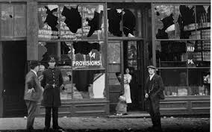
Vancouver Riot, 1907
Many Chinese were in Canada as cheap labourers, due to interest in the Cariboo Gold Rush, the construction of the CPR, and other public works (mines and canneries).
These Chinese didn’t intend to stay, but return once they got more money. They lived in ‘Chinatowns’ in Vancouver, Victoria, Nanaimo, and New Westminster.
Labour councils wanted to restrict Chinese immigration. These opponents formed the Asiatic Exclusion League. In 1907, the Lieutenant-Governor, James Dunsmuir, refused to sign a bill excluding Chinese immigration.
SO:

The Komagata Maru
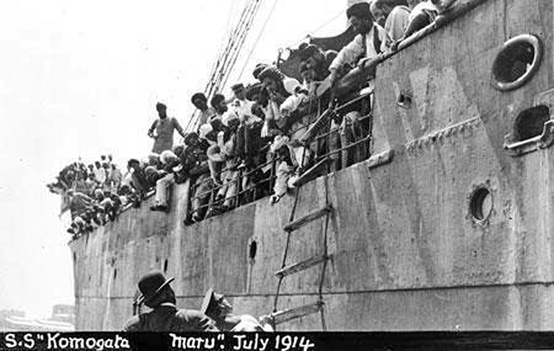
William Lyon Mackenzie King, Minister of Labour, led a Royal Commission to investigate the Vancouver Riots and how Asians were enticed to come to Canada.
It was difficult to restrict East-Indian immigration because they are British subjects, too.
The government amended the 1906 immigration act, stating that all immigrants had to gain entry into Canada through a non-stop, direct route – or ‘continuous passage.’ This was IMPOSSIBLE for people from India.
1914, Gurdit Singh chartered the Komagata Maru to transport 354 Sikh immigrants.
WHAT HAPPENED?

