Name: Block:
The Pacific Scandal
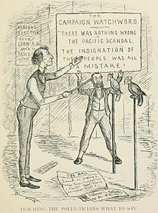
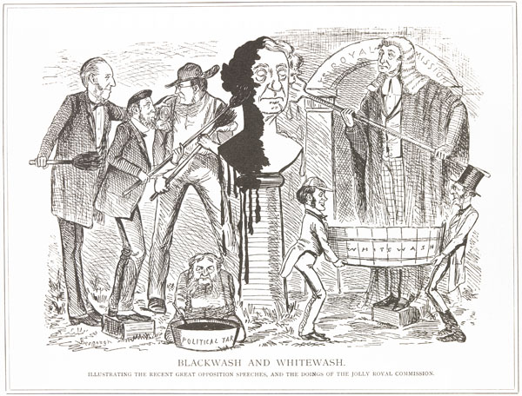
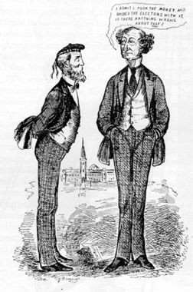
Left: JAM- “I admit I took the money, and bribed the electors with it. Is there anything wrong about that?” Missing text – We in Canada seem to have lost all idea of justice, honor and integrity”
What criticism is being made?

Middle: “Blackwash and Whitewash: Illustrating the recent great opposition speeches, and the doings of the jolly Royal Commission”
What does it mean to ‘whitewash’? Who is the central statue?

Right: On board – “The campaign watchword: There was nothing wrong with the Pacific Scandal. The indignation of the people was all a mistake.” Below – ‘teaching the politicians what to say’
What is JAM doing? What/Who does the parrot represent?

