Name: Block:
Primary Sources: Confederation

Below are a number of political cartoons that discuss the events of the Canadian Confederation. Based on your notes and knowledge of the events during the confederation, answer the questions about each primary source.
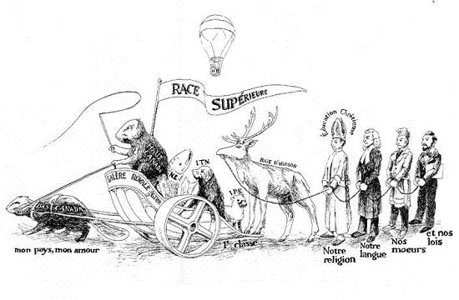
[left to right] My country, my love; Lower Canada; Grand Trunk Railway; Upper Canada; Nova Scotia; superior race; Newfoundland; Prince Edward Island; Hudson Bay; our religion; our language; our customs; our laws.
Based on La Confédération Quadrille Danse Nationale , Montréal, 1865
Whose perspective (point of view) is this cartoon from? What are they afraid will happen because of Confederation? Use evidence to support your argument!

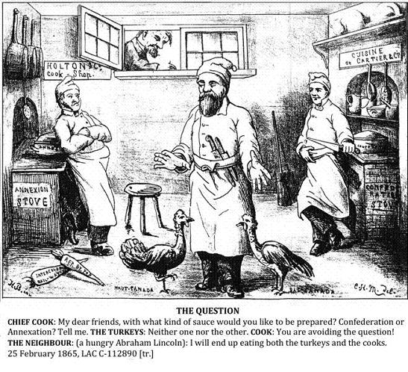
Whose perspective (point of view) is this cartoon from? What are some issues that are presented? What point is the artist trying to make? Use evidence to support your argument!

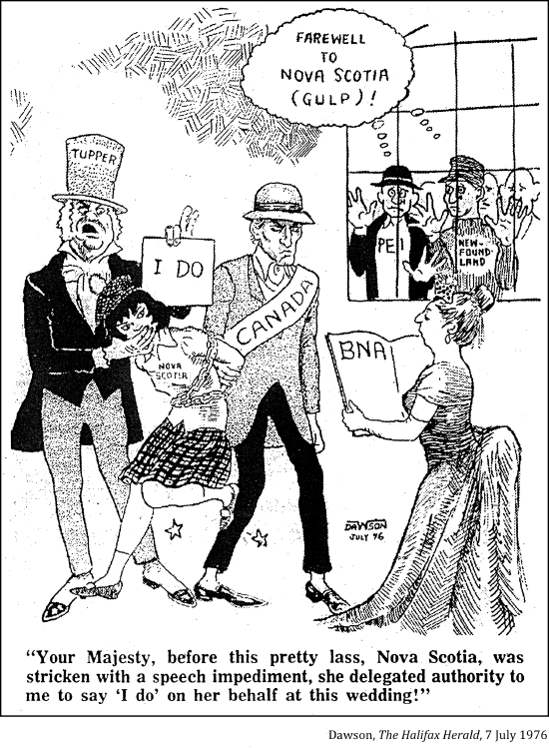
When was this cartoon made? Whose perspective is the cartoon from? Why would this cartoon be made after Confederation? Use evidence to support your argument!

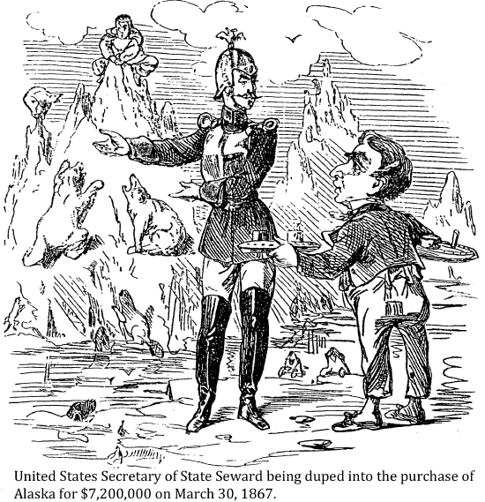
What is the issue being presented? Whose perspective is it presented from? How did this affect Canada? Use evidence to support your argument!

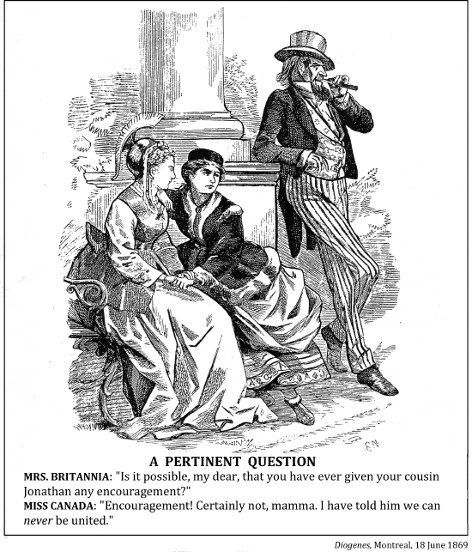
What is the issue being presented? Whose perspective is it presented from? How did this affect Canada? Use evidence to support your argument!

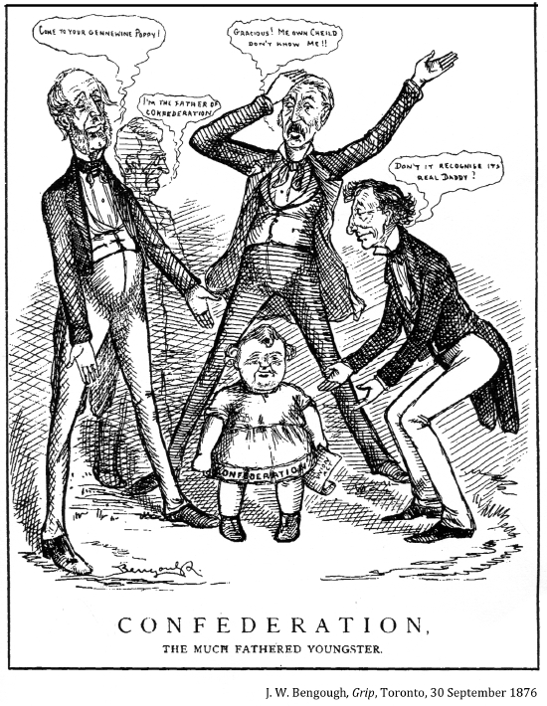
Whose perspective (point of view) is this cartoon from? What are they afraid will happen because of Confederation? Use evidence to support your argument!

