Name: Block:
Sources for the Protestant Reformation
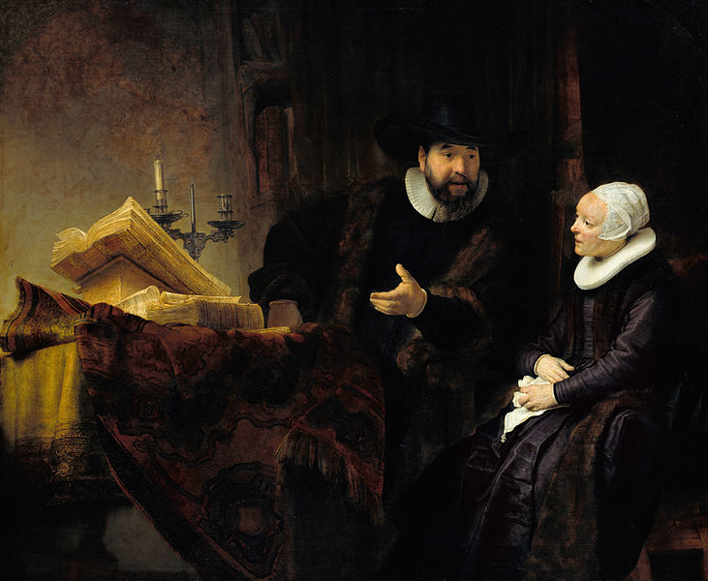
Rembrandt - The Mennonite Preacher Anslo and his Wife – 1641; the scene shows the couple studying the bible
What statement do you think the artist is trying to make? How would art like this help spread the Reformation?
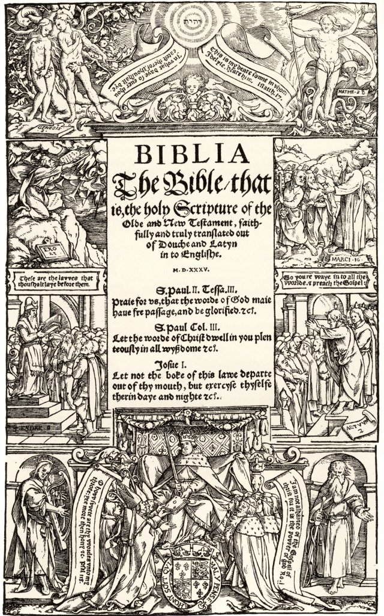
'Title-Page of Coverdale's English Bible', 1535. The Coverdale Bible by Myles Coverdale was the first complete Modern English translation of the Bible.

How is this something that symbolized the Reformation? What did it do to the power structure? What technology did it rely on later?

The following are some examples of John Calvin’s rules for Inns. Calvin set up a Christian state in the city of Geneva in Switzerland and his government was very strict. His “blue laws” were strict, and his followers (of Calvinism) were called Huguenots.
- “The host shall be obliged to keep in a public place a French Bible, in which any one who wishes may read.
- [The host] shall not allow any dissoluteness like dancing, dice, or cards.
- [The host] shall not allow indecent songs.
- Nobody shall be allowed to sit up after nine o’clock at night except informers.”
Why would people want to follow laws like these? How is this different from Catholicism at the time?

Below is a celebration of the French King’s sister, Marguerite of Navarre. She was educated and a freethinker, and she also protected Protestant followers.

“Let us always remember this tender queen of France, in whose arms our people [Protestants], fleeing from prison or the pyre, found safety, honour, and friendship. Our gratitude to you, lovable mother of our Renaissance! Your hearth was that of our saints, your heart was the nest of our freedom.”

How would the protection Marguerite gave have encouraged the spread of Protestantism?

