Name: Block:
Louis Riel and Gabriel Dumont (from Hark! A Vagrant)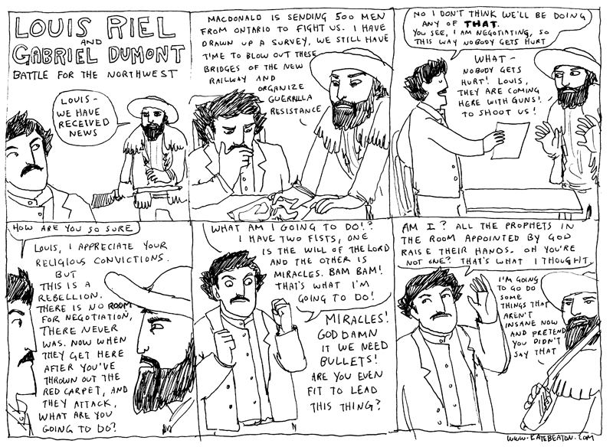
What happened to Riel after the Red River Rebellion?

According to the comic, what sort of person was Louis Riel? How do you know?

According to the comic, what sort of person was Gabriel Dumont? How do you know?

What do you think the outcome of the Northwest Rebellion of 1885 was? Why?

After watching the video clip, what happens to Riel?

