Name: Block:
Robin Hood: Historical Film Analysis
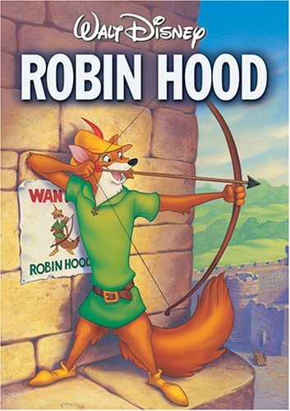
We are going to view Disney’s Robin Hood. The film is from 1973 and has mixed reviews.
Our job will be to look at different aspects of the film and assess them for accuracy.
You may focus on just one point of interest, or all (listed on the backside of this sheet), but you MUST take notes on how each element is presented in the film.
Once you have taken notes on how each element on the medieval period is presented, you will use your notes, handouts, and online resources in order to determine how accurate the portrayal is in a formal paragraph of at least a page in length.
You must include this sheet, with your notes, for your final submission.
You may not say that it is inaccurate based on the fact that the characters are portrayed by animals – that much is obvious!
Happy viewing!

 | How is it presented in the movie? | Is it accurate? Why or why not?
Courtly Love
Robin Hood
King John
King Richard
Tournaments
Feudal Life
The Crusades

