The English Civil War (1642-1649)
The Rump parliament (1648) or “The Tyranny of the majority”
The Rump Parliament is the name given to the Long Parliament after Pride's Purge of December 1648 in which those MPs who sought a settlement with King Charles I were forcibly expelled by the New Model Army (and by Oliver Cromwell). The Rump regarded itself as the lawful Parliament of the Commonwealth of England but the derisive name first used widely in 1660 became its enduring nickname after the Restoration.
Background:
In 1642, those who supported the king, and were against the Grand Remonstrance, left parliament to fight for the king as ‘Royalists’ and ‘Cavaliers’.
Parliament was then controlled by Presbyterians and Puritans.
- Presbyterians wanted churches organized so that everyone worshipped in the same way; they were OK with Charles returning – with limited powers
- Puritans wanted churches run independent of each other; they were republican and wanted the end of monarchy and Charles
THE PURGE:
was presented to Parliament in June 1647 at a time when Presbyterian MPs were attempting to disband the New Model Army (Cromwell) without settlement of the soldiers' grievances after the First Civil War.
On 20 August 1647, Cromwell stationed a cavalry regiment at Hyde Park and marched under armed escort to take his seat in the House of Commons. This display of force coerced many Presbyterians into withdrawing from Parliament, leaving the House of Commons for a time with an Independent majority whose views were broadly in line with those of the Army.
Further discussions and concessions are made between the king and parliament, but many are unhappy. The Army radicals’ attitude was further hardened by the King's alliance with the Scots, which resulted in the Second Civil War during 1648, and by his refusal to compromise in negotiations for a settlement even when the Royalists had been defeated a second time. There is talk of either dissolving parliament or purging it.
After Parliament's fateful vote to continue negotiations with the King, a meeting was held at Whitehall on 5 December between Army officers led by Ireton and Independent MPs, at which Ireton was persuaded to use military force to purge Parliament of the King's supporters rather than dissolve it. A six-member sub-committee of officers and MPs headed by Ireton, Harrison and Ludlow withdrew to a private room to make the detailed arrangements and to prepare the list of MPs who were to be purged.
Colonel Pride was stationed on the steps leading to the entrance of the House of Commons with the list of MPs regarded as enemies of the Army. He was seconded by Sir Hardress Waller and accompanied by Lord Grey of Groby, who identified the proscribed MPs as they approached. The exact number of MPs on the list is not known for certain. Out of a total of around 470 MPs eligible to sit, about 180 were to be "secluded" or prevented from entering Parliament. A smaller number regarded as extremists were to be placed under arrest. At least 100 of the MPs on Pride's list stayed away from Parliament or fled from London, including the leading Presbyterians Denzil Holles and John Glyn.
Pride and his accomplices kept the proscribed members from entering Parliament and arrested about forty-five, including William Prynne, Sir William Waller and Edward Massie. The arrested MPs were held in the nearby Queen's Court throughout the day, where they were badly treated by soldiers who believed that they were responsible for withholding Army pay. The MPs were held overnight under uncomfortable conditions in a nearby tavern known as "Hell" but were transferred to more comfortable quarters in other local inns during the next few days. On 12 December, five of the most extreme Presbyterians (Waller, Massie, Lionel Copley, Sir John Clotworthy and Sir William Lewis), along with the sheriff of London and former major-general Richard Browne, were imprisoned at St James's. Massie escaped in January 1649 but the others were accused of plotting the Scottish invasion of 1648 and remained in prison without trial for several years. The rest of the members arrested during the Purge were released early in 1649.
The Purge was carried out on the orders of Henry Ireton. General Fairfax apparently had no knowledge of it, even though all the Army's actions were carried out under his name. He was said to be furious when he heard what had happened but did nothing to interfere. Cromwell arrived back in London from the siege of Pontefract the day after the Purge and announced his approval of the proceedings. By removing the MPs who still favoured a negotiated settlement, the Purge effectively cleared the way for the King's trial the following month.
Initially, only around eighty MPs sat in the purged Parliament, though their numbers increased after the execution of King Charles and the declaration of the Commonwealth early in 1649. The purged House of Commons came to be known as the Rump Parliament.
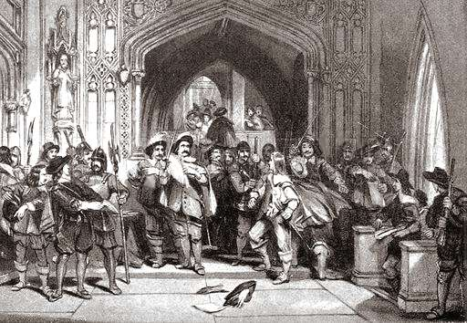
From: http://bcw-project.org/church-and-state/second-civil-war/prides-purge

Questions:
- Who was unhappy with the parliament before the Purge?

- Why were they unhappy?

- What was the role of Oliver Cromwell?

- What were the names and roles of other organizers?

- What is the meaning of ‘the tyranny of the majority’?

- Could the parliament that charged Charles I with treason, still be considered a democracy?

- Create a visual representation (comic strip, diagram, etc) of what happened during the Purge.

