Name: Block:
Ships and Navigation: Early Exploration
How did early Sailors navigate the Oceans?: Video Questions
- According to the video, what did Vikings do to navigate?

- Who were the first to use the motion of the stars, weather, wave size, and animals to navigate?

- What is the best star to use for navigation? Why?

- Why was having an accurate clock important for navigation?

World Explorers in 10 Minutes: Video Questions
- What are some characteristics an explorer must have?

- Do you think you could be an explorer? Why?

- How did explorers influence history?

- Which explorer had the greatest influence on history? Why?

- What are the similarities between maritime exploration and space exploration?

- What is the most interesting new fact you learned?
Pathways Questions
Take a look at the ships on page 248-249. How did sailing technology and ships change over time?

Page 250: Describe the following inventions and how they were used in exploration.
Compass:

Log Line:

Quadrant:

Traverse Board:

Page 253: According to the text, what are some practical uses for longitude and latitude? Can you think of others?

Page 253: What is Greenwich Mean Time? Where is Greenwich located? What does ‘Eurocentric’ mean? How does this relate to GMT?

Page 253: On the circles below, draw lines of longitude and latitude for 0 degrees. Label the North Pole (and the degree), the South Pole (and the degree), The Equator (and the degree) and the Prime Meridian (and the degree).
Next, label Vancouver, and identify the longitude and latitude. Pick 5 other locations to label and identify the longitude and latitude.

Front

Back

Look at both of these maps and focus on where the continents are:
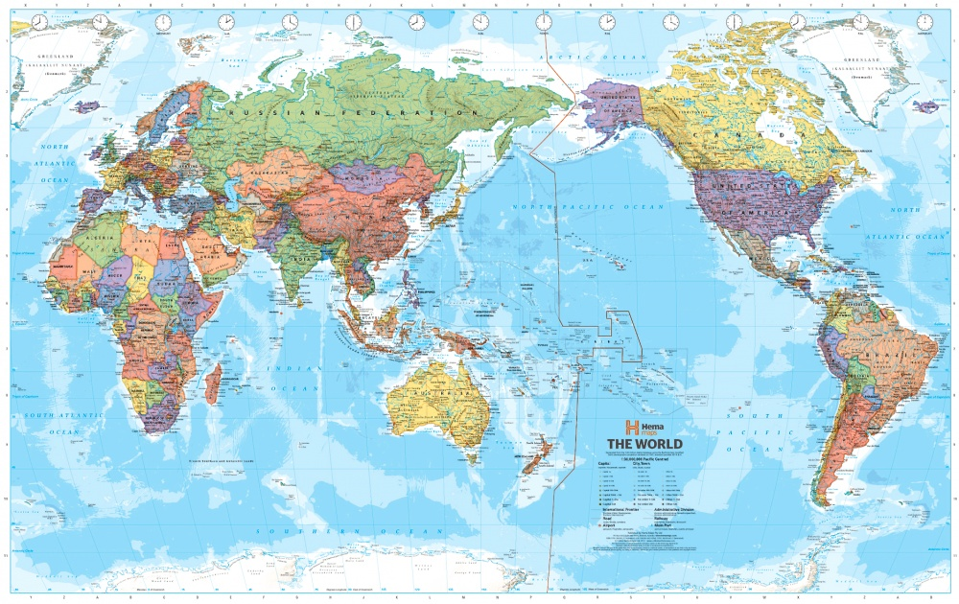
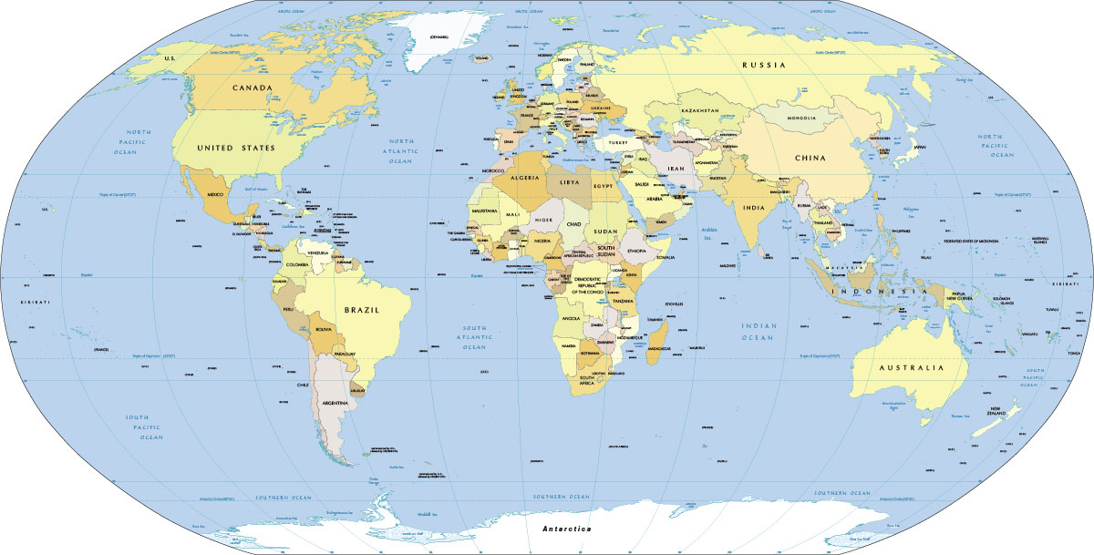

Which map represents the world in a better way? Why? Which one have you seen more often? How are different people’s perspectives represented in maps when we focus on different areas of the world?

Pretend that you are an early explorer. Sketch out a map of the world below that best reflects how you see the world. Is it accurate?

