Poster Assignment

Your job is to create a poster that informs and educates people about common spelling or grammar issues. Take a look online to see examples of what and how you can present your ideas.
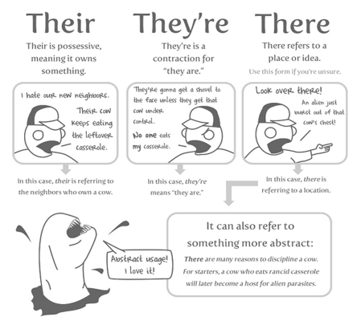

Use any combination of humour, description, and explanation, as long as the message is clear. You will be assessed based off of the clarity of your message and the evidence of effort.
Here are some ideas:
Which vs that
A lot or alot
Their, they’re, there
Affect vs effect
Then vs than
Your vs you’re

Make sure to pick a unique issue to your table group because you will be presenting it to them!

