Name: Block:

How the Spice Trade Changed the World

But first, some history… The Fall of Constantinople, 1453
Overview (http://www.thenagain.info/WebChron/EastEurope/FallConstantin.html)
The siege of Constantinople, the capital of the Byzantine Empire and one of the most heavily fortified cities in the world, took place in 1453. Sultan Mehmed II, ruler of the Ottoman Turks, led the assault. The city was defended by, at most, 10,000 men. The Turks had between 100,000 and 150,000 men on their side. The siege lasted for fifty days. The Turks employed various important war tactics in taking over the city. They used huge cannon to destroy the walls; warships were used to the cut the city's sea defense. They also used an extensive infantry to engulf the city.
Video: Fall of Constantinople (Reply History)
Where is Constantinople located?

What was Constantinople still a part of before its fall?

What is remarkable about this battle?

How did the fall of Constantinople affect its citizens?

How did the fall of Constantinople affect Europe?

What is Constantinople called now?

Consequences (from: http://www.deseretnews.com/article/865580842/This-week-in-history-The-Fall-of-Constantinople-had-profound-consequences.html)
The significance of the fall of Constantinople cannot be overstated. The sultan soon proclaimed Constantinople his new capital, and Islam gained a foothold in Eastern Europe. For the next 2 1/2 centuries, Christian Europe, which had failed to come to Constantinople's side in its time of dire peril, feared the intrusion of Islam into the continent. Islamic Ottoman armies twice advanced into Europe and laid siege to Vienna — first in 1529 and again in 1683.
Another important legacy of this battle is still present throughout the Islamic world today. The city of Constantinople had a profound hold on the Islamic imagination for centuries. Army after army had failed to take it, and in the Islamic minds the city became the focal point of resistance to their religion and their God. On that Tuesday morning 560 years ago when the city finally fell, a crescent moon hung in the sky. Today, Islamic nations around the world commemorate the military victory of 1453 with crescent moons on their flags.
The fall of Constantinople also had profound consequences for Europe. Many Greeks and other Balkan peoples, fearing death or forced conversion to Islam, fled westward across the Adriatic Sea to Italy. Many of these refugees took with them vast riches of ancient art and knowledge, helping to ignite the Renaissance.
Summarize the 3 main consequences for the fall of Constantinople:
1.

2.

3.

THINK: What could this change in power due to existing trade relationships with Europe?
Video: Crash Course, Venice and the Ottoman Empire
- How is Venice described? The Ottoman Empire?

- Why was the relationship between Venice and the Ottoman Empire successful?

- How did this relationship affect exploration (from different countries)?

Supply and Demand
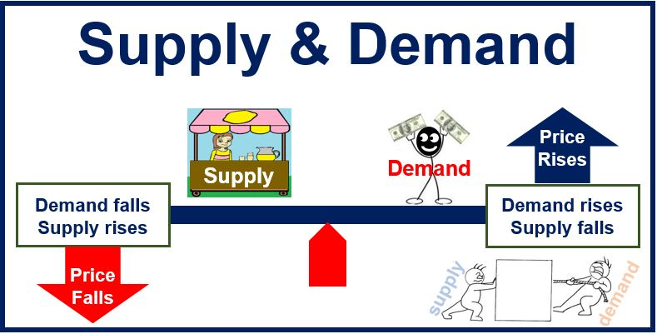
Define Supply and Demand:
Supply:

Demand:

Take a look at the 7 scenarios with a partner. Summarize the information, and then decide whether the scenario affects supply or demand.
Scenario Number | Summary | Supply | Demand
1
2
3
4
5
6
7
Spice Math: Today and the Past
In order to understand the importance and value of spices in times past and today, we are going to do some math and search for some groceries on realcanadiansuperstore.ca and saveonfoods.ca. You must include one item (of your choice) from each website.
Ground Black Pepper
Brand | Price | Grams in container | Price per gram  (price divided by gram) | Price per pound  (price/gram, then multiplied by 453.59)
Ground Cinnamon
Brand | Price | Grams in container | Price per gram  (price divided by gram) | Price per pound  (price/gram, then multiplied by 453.59)
Whole Cloves
Brand | Price | Grams in container | Price per gram  (price divided by gram) | Price per pound  (price/gram, then multiplied by 453.59)

To compare today’s prices with those from the past, we need to use something other than today’s dollars. A workman in England in 1439 did not use U.S. dollars to buy his cinnamon! One way is to find out how long the English workman would have had to work to pay for a pound of cinnamon. Historian John Munro has calculated wages for an average craftsman in England in 1439. He found that an average workman would have had to work two days to comparison buy a pound of black pepper, three days to buy a pound of cinnamon, and 4.5 days to buy a pound of cloves. How many days would the average worker in the United States have to work to afford the same amounts of the same spices today? Assume that today’s average daily wage is $170.
Comparing Today’s Prices with Prices in 1439
 | Avg. price per pound  (add 2 prices and divide by 2) | Number of workdays needed to buy one pound today  (Avg. price per pound ÷ $170) | Number of workdays  needed to buy one pound in 1439
Black Pepper |  |  | 2 days
Cinnamon |  |  | 3 days
Cloves |  |  | 4.5 days

QUESTIONS:

- In terms of the number of workdays it takes to buy spices, has the price of black pepper increased or decreased?

- In terms of the number of workdays it takes to buy spices, has the price of whole cloves increased or decreased?

- In terms of the number of workdays it takes to buy spices, has the price of cinnamon increased or decreased?

- In 1439, which spice was cheapest?

- Today, which spice is cheapest?

Supply and Demand: Today
Research one item, explaining how supply and demand affect the cost of that item. For example, is it a product that is made in another country? What would be involved to get that product to a local store today (consider also what store it would be sold in or if it is an object you would purchase online).

