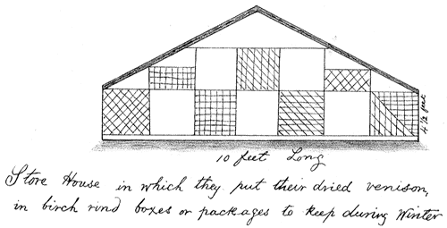  Shanawdithit's Sketch of a Store-House, Inhabitants of Newfoundland (Cambridge: University Press, 1915) following p. 248.From James P. Howley, The Beothuks or Red Indians: the Aboriginal | Thanksgiving Bonus Points! Be thankful for Socials  You have the opportunity to bring to class on Thursday a food that is inspired by one of the indigenous foods of Canada. It must have some link to the type of food that existed before settlers came to Canada. If you provide justification for your choice to me in class, you will get 5 extra points. If you need further clarification, visit our class website: msvandclass.weebly.com

Shanawdithit's Sketch of a Store-House, Inhabitants of Newfoundland (Cambridge: University Press, 1915) following p. 248.From James P. Howley, The Beothuks or Red Indians: the Aboriginal | Thanksgiving Bonus Points! Be thankful for Socials  You have the opportunity to bring to class on Thursday a food that is inspired by one of the indigenous foods of Canada. It must have some link to the type of food that existed before settlers came to Canada. If you provide justification for your choice to me in class, you will get 5 extra points. If you need further clarification, visit our class website: msvandclass.weebly.com

Shanawdithit's Sketch of a Store-House, Inhabitants of Newfoundland (Cambridge: University Press, 1915) following p. 248.From James P. Howley, The Beothuks or Red Indians: the Aboriginal | Thanksgiving Bonus Points! Be thankful for Socials  You have the opportunity to bring to class on Thursday a food that is inspired by one of the indigenous foods of Canada. It must have some link to the type of food that existed before settlers came to Canada. If you provide justification for your choice to me in class, you will get 5 extra points. If you need further clarification, visit our class website: msvandclass.weebly.com

