The Biggest Holocaust in World History
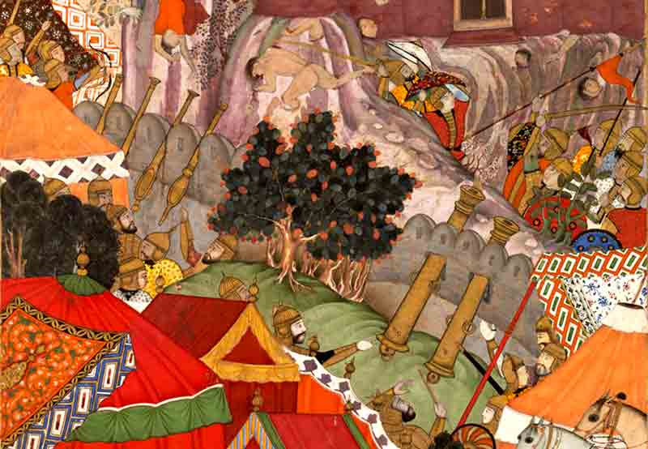
Jauhar', or burning, of the Rajput women following the fall of the fortress of Chitor in 1568
by Jayaram V
Sectarianism, bigotry, and its horrible descendant, fanaticism, have long possessed this beautiful earth. They have filled the earth with violence, drenched it often and often with human blood, destroyed civilization, and sent whole nations to despair. Had it not been for these horrible demons, human society would be far more advanced than it is now. Swami Vivekananda (1893)
With the invasion of India by Mahmud Ghazni about 1000 A.D., began the Muslim invasions into the Indian subcontinent and they lasted for several centuries. The Muslim invasions continued even when the Muslims were ruling India, like the invasion of the Mongols during the reign of the Khiljis or the invasion of the Mughals in the early sixteenth Century when the Lodis were ruling Delhi. The last notable invasion of the Muslims from outside was the invasion of Nadir Shah in 1739, during which he unleashed a great horror on the native population.
During these seven hundred years of Muslim invasions and their conquest and rule of India, the Hindus were the greatest sufferers. It is difficult to estimate the number of Hindus who lost their lives during these campaigns, the number of Hindus who died because of the religious persecution perpetrated on the native population by the Muslim rulers, and the number of Hindus who were forcibly converted to Islam.
According to Prof. K.S. Lal, the author of the Growth of Muslim population in India, the Hindu population decreased by 80 million between 1000 AD, the year Mahmud Ghazni invaded India and 1525 AD, a year before the battle of Panipat.
One can safely add another 20 million Hindus to this list to account for the number that were killed during the Mughal rule or the rule of the Muslim rulers in the Deccan plateau. By all known accounts of world history, as pointed out by Koenard Elst in his book the Negationism in India, destruction of about 100 million Hindus is perhaps the biggest holocaust in the whole world history.
Europe never forgot or forgave the atrocities of the Nazi rule under Hitler. We hardly come across any positive reference to either Hitler or his army in the present day text books on European History. No one talks there of the qualities of Hitler as a great commander or an inspiring leader of German people whom he could mould and influence with his hypnotic speeches. No films are made showing Hitler as a romantic hero singing songs and his mistress as a heroine shedding copious tears over her lover!
The European consciousness is filled with the evil deeds perpetrated by his regime, thanks to the untiring work of their politicians, journalists, historians and film producers, so much so that the very thought of seeing any virtue in either Hitler or Nazis is abhorrent to the consciousness of the present day Europeans.
Europe and America produced at least a few thousand films highlighting the human misery caused by Hitler and his army. The films expose the horrors of Nazi regime and reinforce the beliefs and attitude of the present day generation towards the evils of the Nazi dictatorship.
In contrast look at India. There is hardly any awareness among the Indians of today of what happened to their ancestors in the past, because a great majority of historians are reluctant to touch this sensitive subject. It is not difficult for the Indian historians to gather information on the kind of atrocities perpetrated against the people of medieval India, to work out the estimated number people killed in the reign of each ruler, to create vivid pictures of what happened during such battles as the battle of Tallikota when Hampi, the capital of Vijayanagara empire was systematically destroyed for weeks.
Nadir Shah made a mountain of the skulls of the Hindus he killed in Delhi alone. Babur raised towers of Hindu skulls at Khanua when he defeated Rana Sanga in 1527 and later he repeated the same horrors after capturing the fort of Chanderi. Akbar ordered a general massacre of 30000 Rajputs after he captured Chithor in 1568. The Bahamani Sultans had an annual agenda of killing a minimum of 100000 Hindus every year. The history of medieval India is full of such instances.
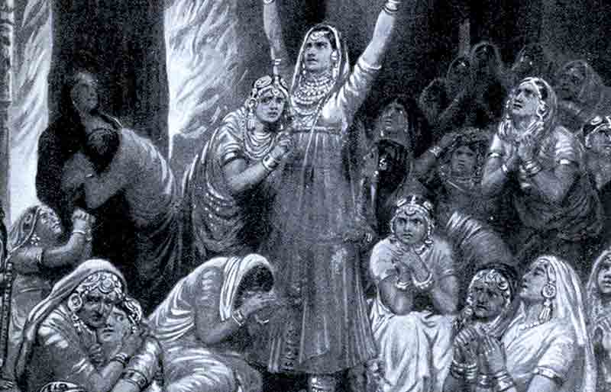
The Rajput ceremony of Jauhar (holocaust), 1567, illustration from 'Hutchinsons History of the Nations'
And against this background, look at the films we have produced so far in a country which boasts of the largest film industry in the world, with no dearth of talent and workmanship! We have films like Mugal-e-Azam, Anarkali, or Taj Mahal which romanticize the Mughal rulers, depicting them as great heroes of noble virtues oozing with kindness and love for the humanity! The heroes of Anarkali and Taj Mahal were next to Aurangazeb in their persecution of Hindus and Sikhs. But people are made to see them as romantic heroes and remember songs from these movies with great nostalgia!
One may say why dwell upon unpleasant facts. True, but can we develop the character of a nation without facing the realities of life, however unpleasant they may be? Can we develop the maturity of thought that comes with the sense of suffering and the sense of responsibility? The purpose of knowing these facts is not to heap vengeance, but to strengthen our national character, to avoid the weaknesses that were responsible for the plight of our ancestors. The Muslims of present day India are also part of this character building because they must know that their ancestors also suffered, that as far as the past is concerned all Indians were in the same boat and that there were no victors and no losers in that great human tragedy. Knowing thus, perhaps they would develop proper wisdom and understanding and right attitude towards other communities.
Finally, in what context do we talk of Hitler and Nazis in India?
The answer is even more disturbing. Anyone who speaks for Hindus is a Hitler or is in the process of becoming one and any group which speaks for Hindus are Nazis or are in the process of becoming Nazis!

Where is there evidence of bias in this article?

What does sectarianism mean?

Why does the author believe it is worthwhile to discuss past religious persecution?

Why don’t people in India discuss past atrocities? How would the people be treated if they did?

Why doesn’t popular culture treat these events the same as the Holocaust?

After watching “What are the worst countries for Christians”, write below what the most striking fact you heard is.

When discussing religion, why do people use war-like terms like ‘attack’? Is using these types of words good?

