Name: Block:
The Bill of Rights (1689)
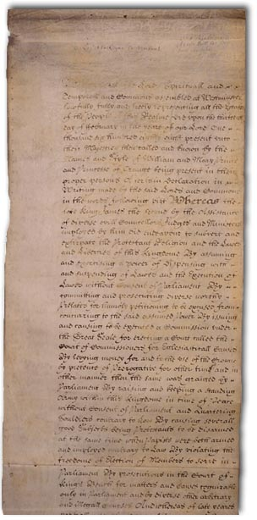
The Bill of Rights 1689 is an English Act of Parliament with the full title An Act Declaring the Rights and Liberties of the Subject and Settling the Succession of the Crown and also known by its short title, the Bill of Rights.
Some highlights; summarize the following in your own words in the space provided below:
- That the pretended power of suspending laws, or the execution of laws by regal authority without the consent of Parliament is illegal.

- That it is the right of the subjects to petition the King, and all commitments and prosecutions for such petitions are illegal.

- That the election of Members of Parliament ought to be free.

- That freedom of speech, and debates or proceedings of Parliament, ought not to be impeached or questioned in any court or place out of Parliament.

- That excessive bail ought not to be required, nor excessive fines imposed, nor cruel and unusual punishments inflicted.

- And that … parliaments ought to be held frequently.

Think of rulers during the time of the English Civil war that have broken any of these rights. Connect them to a date or specific event if possible. Who is the worst offender?

Take a look at the following website: http://avalon.law.yale.edu/17th_century/england.asp
In your opinion, what is James II’s worst crime?

In your opinion, what is the most important right declared? Would the parliament agree with you?

Think of all of the things that were happening during the English Civil War. Decide on the three most important rights and record them below. Justify each choice using historical evidence!
1.

2.

3.

