Name: Block:
The Columbian Exchange: Video
What does “new world” mean?

Why would they call this period (15th and 16th centuries) the Columbian exchange?

What positive changes happened because of the Columbian exchange?

What negative change happened because of the Columbian exchange?

What happened to pre-existing North (and South) American civilizations?

Summarize the impact of diseases to both sides:

Summarize the impact of animals to both sides:

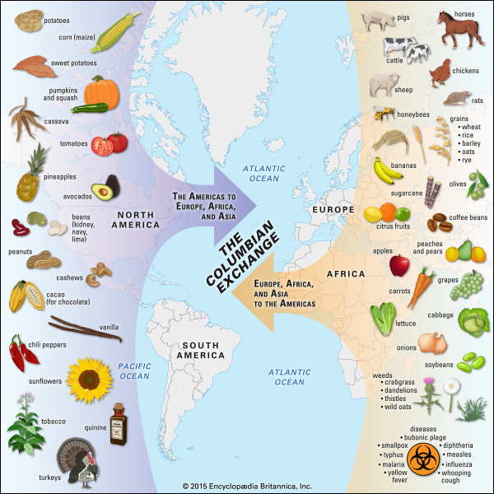
Summarize the impact of plants to both sides:

Look at the graph to the right. What’s the most surprising item that was exchanged?

