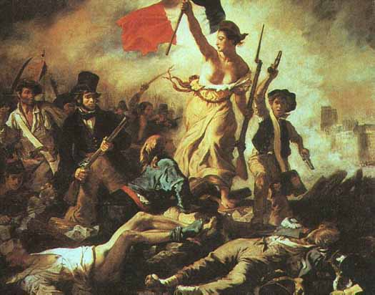
The French Revolution

Life in France in the 17th Century

France was still a Medieval hierarchy in the
1600s. The King ruled, while ____________________ (Nobility)
and the __________(Clergy) held many privileges. The Church
could tax peasants 10% of their income (a tithe)

Peasants - in the countryside
French ___________________ (farming) in the 1600s was less effective and less modernized with other European countries

They used ________________________ and made much less __________________
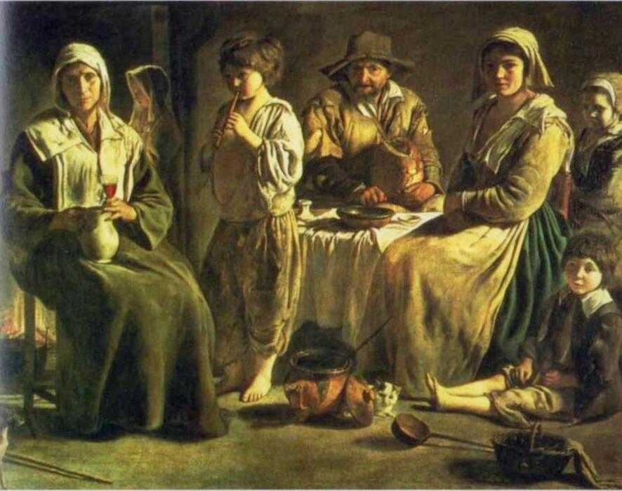
Almost all peasants who worked on the _____________________________________, and worked long brutal hours for a poor quality of life

Paris - largest city in France with pop. 600,000

Peasants - in the city
Most people who lived in Paris or other cities were peasants from the countryside seeking work
Many had no jobs, and those who did _________________________________________________________.

Inflation was a huge problem. There were many homeless, criminals, and thieves.

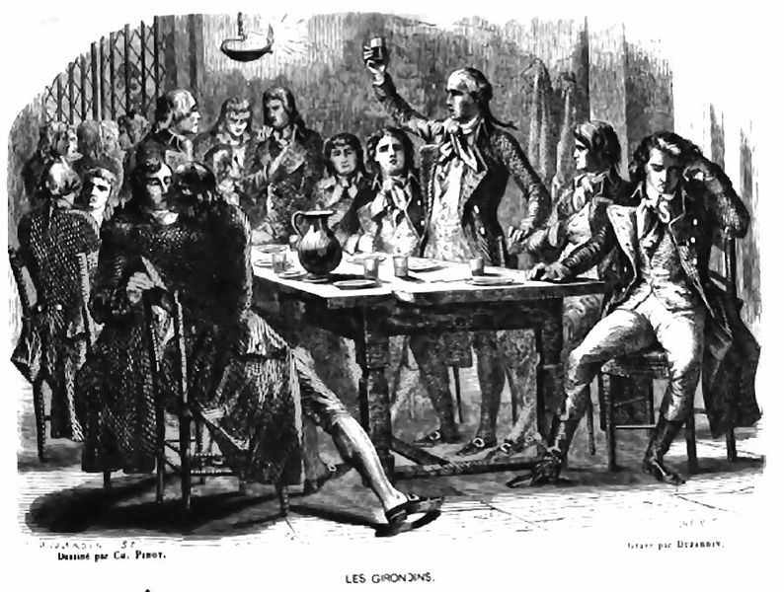
The small percentage of wealthy merchants and aristocrats ___________________________________ in plain sight

The Bourgeoisie
The bourgeoisie was France’s _____________________________.
Many were businessmen and merchants.
However, their ability to make a profit was ________________________________________________.
Some individuals and groups (_________________) held advantages (_________________________) over the production of certain goods
France lacked “______________________________”: basic and effective services for the people, like roads, canals, means of communication

Also, France was divided into _____________________, with separate ______________________________. Overall, this made French economy and daily life old-school and ineffective

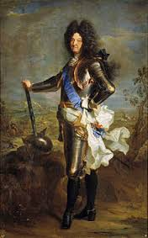
Louis XIV (the 14th)

“__________________” - the name he gave himself
He thought he was the centre of France and people’s lives
“Etat c’est moi”: ____________________________

He forced nobles to live in his palace in Versaille with them, and
he _____________________________________________________________________
(He forced them to learn ballet!)

Louis XIV ruins the economy
Louis XIV became ___________________________________________, and many were unsuccessful.

He gave himself special rights within the Roman Catholic Church, and _______________________
_________________________________ (Protestants who followed the philosophy of John Calvin)

He died in 1715, and his son, Louis XV (the 15th), became king at age 5. The economic wastefulness of his father continued, as did the _________________________________________________
_____________________________________________________________

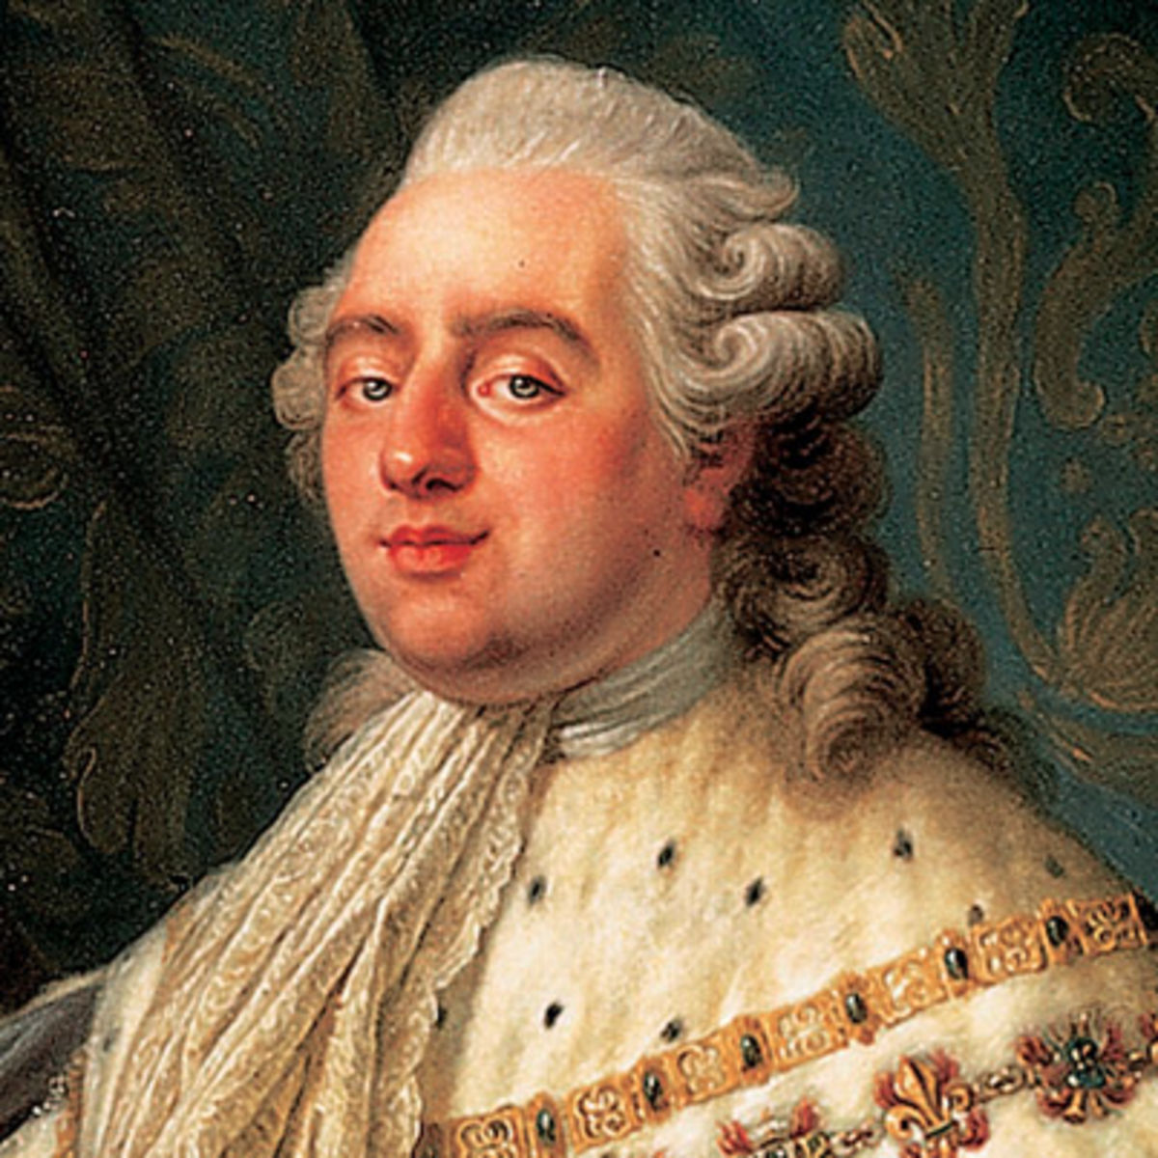
Louis XVI (the 16th)
The next Louis was not equipped to be ruler. He was not

___________________________________________________________,
and was _________________________________________________
about the problems of the middle and lower class people

Problems, such as ______________________________________________________________ in different parts of the country, continued.

The educated middle class could not understand why changes were still not happening

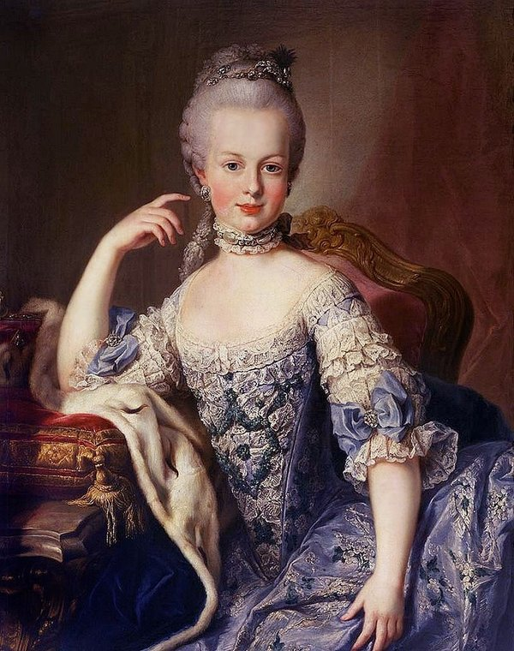
Marie Antoinette
In 1770, Louis XVI marries Marie Antoinette,
member of the __________________________________
(so people didn’t trust her immediately)

Marie Antoinette loved fine things like jewelry,
fancy clothes and customs

______________________________________________________
and did not realize it was horribly difficult

“Let them eat cake!”
After the French Revolution, and not during, many people believed that Mary Antoinette said this______________________________________________________________________________________________ during famines created by her husband, the king.

She never said it, but people use the phrase to remember her _________________________________ ___________________________________________________towards the poor and suffering in her country, while she was filthy rich and wasteful

The Affair of the Diamond Necklace
Quick Google search! In YOUR OWN WORDS, summarize the Affair of the Diamond Necklace and explain its consequences for Marie Antoinette.

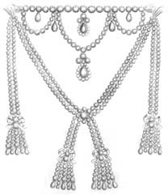

France in Crisis

During the reign of Louis XVI and Marie Antoinette, France was nearly ___________________, and this hurt _______________________________________ the most

The country also suffered from ____________________ during the 1780s; thousands were starving and many __________________________ roamed the streets of Paris and other cities

The Royal Court itself was split into those who _________________________________________________ and changes to the economy, and those who __________________________________________________ and more power to the nobles

The middle class and some aristocracy wanted more democracy; they were inspired by the _________________________________________________________________and the freedoms that the _________________________________________ brought to the colonies

The philosophes were embarrassed by how ________________________ France was compared to the England and the United States

America | England | France

Britain’s ________________________________________ was causing unemployment in France

Machines could be used to make textiles instead of people, and it was cheaper to import these from England then to make them in France

The “_______________________________” rioted against the inflated prices of bread, and the king’s troops responded by shooting dozens of them
The Estates General
The Estates General was France’s version of parliament
Three estates (social classes):
- The First Estate: _____________________________________________
- The Second Estate: _____________________________________________
- The Third Estate: _____________________________________________

They rarely met (not since 1614). Each estate voted as a ____________ (together as a group)
The third estate had ________________________________________________________, but the upper class (1st and 2nd estates) had ________________________________________

Louis ordered the Estates General to meet in 1789 to deal with the financial crisis

He didn’t want to really give them any more power, but they demanded it

After 6 weeks of little progress, the Third Estate broke off to form a new government known as the _________________________________, hoping to create a new constitution for France
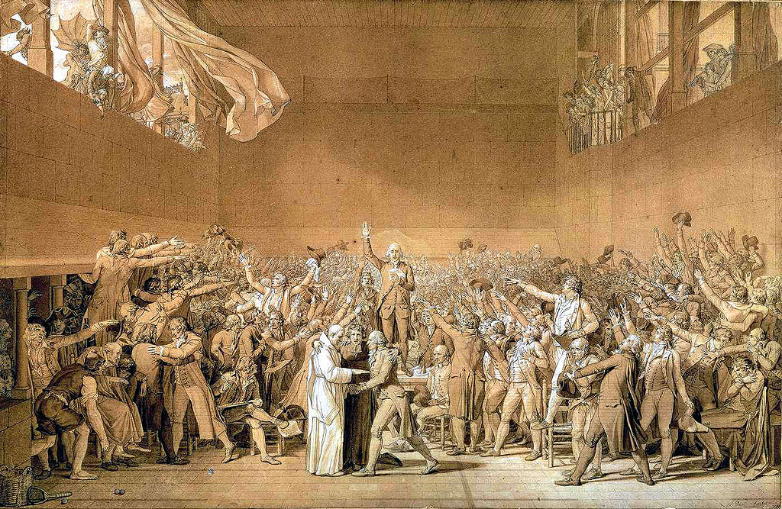

The Tennis Court Oath

The King _______________________ to the Third Estates meeting and blocked it with guards
The Third Estate met in nearby ________________________, and took a _____________________________

"not to separate, and to reassemble wherever circumstances require, until the constitution of the kingdom is established"

Louis tried to appease them with some small reforms, but the Third Estate rejected them.

Louis was forced to back down and order the other two estates to join the Third Estate.
The Revolution looked to be a success...

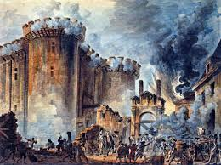
The Fall of Bastille

… But the peace did not last long. Violence was getting out of control

Riots continued over the ____________________________________________________, and Louis hired _____________________________ to try to suppress the rioters

July 14th, 1789 (now _________________________ in France) a huge mob attacked the Bastille royal prison. All _____________________________________ were released, and the mob cut off the governors head and paraded it through the streets!

Louis was forced to send the mercenaries away
The Third Estate formed a new army called “______________________________________”

The Women’s March on Washington Versailles

In August, 1789, The National Assembly met in Versailles and abolished all feudal rights and privileges and ended serfdom

They declared ALL people __________________________________________

Still, people believed that the King and National Assembly was ____________________________ and need to be in __________________________________________________________________

In October, _______________________________________ met in Paris to march to Versailles (50km!)
Thousands of women ________________________________________________ and stormed the palace. The king and queen were forced to return to Paris

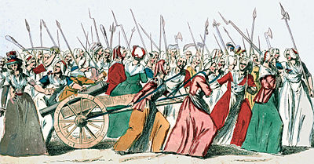

The Declaration of the Rights of Man and the Citizen

Also in August 1789, the National Assembly passed the Declaration of the Rights of Man and the Citizen

Like the American Declaration of Independence, it sets out basic human rights and the powers of government. It guaranteed:
- Freedom ________________________________________________________
- Limited __________________________________________________________
They then started working on a _________________________ and seized church property to be sold off, the money to be assigned to the people

Louis, Marie Antoinette, and their children tried to ____________________________________
They wanted to obtain _________________________ to help _______________________________
They were arrested, imprisoned, and Louis had to accept France’s new Constitution

The people realized that the Monarchy would not accept change and could not be trusted

A _____________________________________ was formed, and tried to create a workable government
But too many groups didn’t agree with each other:
- Radicals wanted a __________________________________
- Moderates wanted a ___________________________________________________
- Monarchists wanted to _________________________________________________

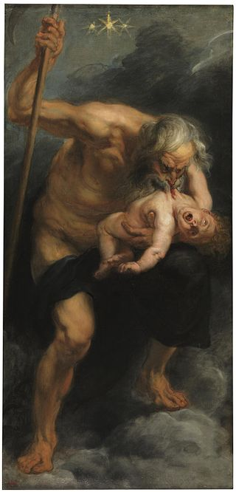
The Revolution devours its own children “Saturn”

In the final years of the French Revolution, _____________________________________
Political parties didn’t exist in France yet; but there were 2 political “clubs”:
- The ____________________ (most from the area of France “Gironde”)
- The _____________________ (who met at the monastery of St.Jacques)

They were originally part of the same group, but the Jacobins became
___________________________, and considered the Girondists too ____________________________________

There was a struggle for power, and the Jacobins won
Most of the Girondists were sent to the guillotine

The Sans-Coulottes

The Sans-Coulottes (“without breeches”) were the ____________________________________________
They were _______________________________________________________________________ and any reforms that would help the business class

In large mobs, they attacked anyone they suspected of being against the revolution

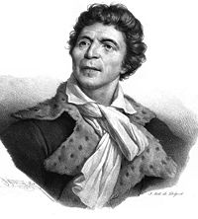
Jean-Paul Marat

The Sans-Culottes wanted to execute the king and all the aristocrats

Their leader Jean-Paul Marat, a politician, physician and writer
and __________________________________________________

They even guillotined a leader of the Girondists, _______________________

Marat we _____________________________________ by a Girondist named “Charlotte Corday”
Two other leaders took charge of the National Assembly and the Revolution

Jacques Danton - Maximillian Robespierre
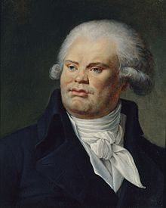
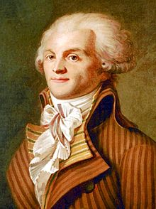

Danton and Robespierre were the other leaders of the Revolution, and they _________________ __________________________________ after Marat’s death

The Revolutionary Wars

Worried about outside European nations trying to invade and restore the king’s power, the National Assembly took part in many conflicts

After many defeats, France had some big victories and gained territories in ________________ ______________(the Louisiana Territory), _________________, and other parts of _____________
These victories ensure the spread of revolutionary ideas around the western world

Heads are gonna roll

Eventually, the King Louis XVI and Marie Antoinette ________________________________________, and it was __________________________________________
Louis was tried for his crimes, found guilty, and ______________________ January 21st, 1793
Marie Antoinette was _______________________ in October

The Reign of Terror

Now, the Jacobins and Sans-Coulottes _______________________________________

In the years 1793-1794, known as the “Reign of Terror”, over 37,000 people were guillotined and many ____________________________________________________

For instance, “____________________________________”: anyone of noble family or political position before the revolution could be arrested

Even __________________________________ was arrested and guillotined, leaving Maximillian Robespierre to act as dictator

The Rule and Fall of Robespierre

Robespierre eliminated all opposition and ___________________________________________________: the metric system, a new calendar, more efficient army, better education systems

But ____________________________________, and France began to turn on him. When he tried to condemn and arrest more people, he himself ____________________________________________________

He tried to ____________________________________________, but only injured himself. He, his closest friends and relatives, were all guillotined. The Reign of Terror was over.

Research Robespierre’s arrest and execution
Really! It’s crazy!

The Directory
After the death of Robespierre, France was ruled by “The Directory”, ________________________
______________________________________

It gave power to _________________________________; only they could vote and elect members to government
So the fight for equality in the French Revolution ended and the lower classes found themselves ___________________________________________________________

But the Directory would be eliminated by a man with one hand in his pocket who would call himself Emperor...
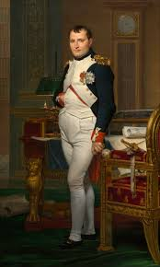

Napoleon Bonaparte

