Name: Block:
The Laurier Boom!
Population Growth by Province, 1891-1921
Year | Manitoba | Saskatchewan | Alberta | BC | Yukon | Canada
1891 | 152,506 | * | * | 98,173 | * | 4.83M
1901 | 255,211 | 91,279 | 73,022 | 178,657 | 27,219 | 5.37M
1911 | 461,394 | 492,432 | 374,295 | 392,480 | 8,512 | 7.21M
1921 | 610,118 | 757, 510 | 588,454 | 524,582 | 4,157 | 8.79M
* Albert, Saskatchewan, and the Yukon became territories in 1898
Take a look at the population graph. What do you notice? How do the numbers change in the prairies? What are some reasons why there are differences? Can you explain the decline in population in the Yukon?

Largest Cities in Canada, 1911 and 1996
 | 1911 | 1996
Montreal | 491,000 | 3,328,000
Toronto | 382,000 | 4,338,400
Winnipeg | 382,000 | 676,500
Vancouver | 101,000 | 1,826,800

What patterns do you notice about the growth of population in these cities? Can you think of some reasons that would affect population growth?

“The Last Best West”
Clifford Sifton became Laurier’s Minister of Interior (in charge of immigration). He managed to bring in many new settlers into western Canada from different areas in Europe, including Eastern and Central Europe. These immigrants were greeted with different levels of enthusiasm.

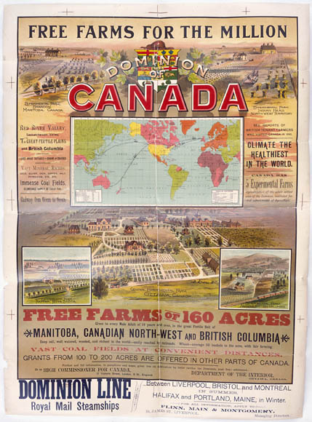
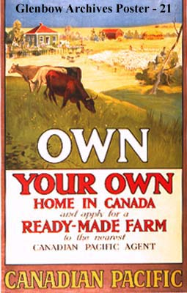
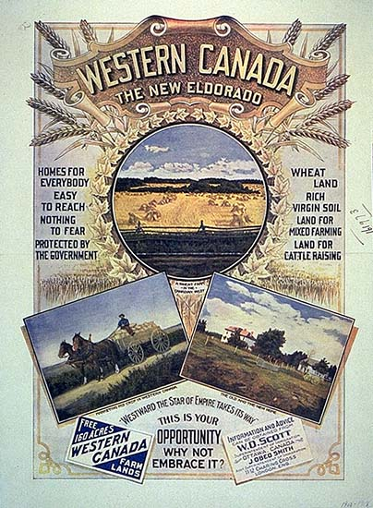
What do you notice about these posters? Where is there exaggeration? Why would people be persuaded? Would the prairies actually look like this?

What is a “push-pull” factor? What are some push and pull factors for your own travels to Canada?

