The Magna Carta (1215)
"The democratic aspiration is no mere recent phase in human history . . . It was written in Magna Carta."
--Franklin Delano Roosevelt, 1941 Inaugural address
On June 15, 1215, in a field at Runnymede, King John affixed his seal to Magna Carta. Confronted by 40 rebellious barons, he consented to their demands in order to avert civil war. Just 10 weeks later, Pope Innocent III nullified the agreement, and England plunged into internal war.
Although Magna Carta failed to resolve the conflict between King John and his barons, it was reissued several times after his death. On display at the National Archives, courtesy of David M. Rubenstein, is one of four surviving originals of the 1297 Magna Carta. This version was entered into the official Statute Rolls of England.
Enduring Principles of Liberty
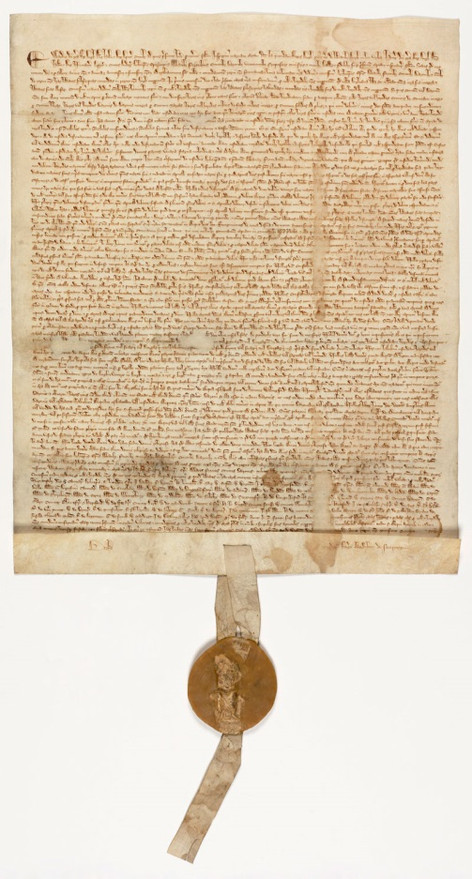
Magna Carta was written by a group of 13th-century barons to protect their rights and property against a tyrannical king. It is concerned with many practical matters and specific grievances relevant to the feudal system under which they lived. The interests of the common man were hardly apparent in the minds of the men who brokered the agreement. But there are two principles expressed in Magna Carta that resonate to this day:
"No freeman shall be taken, imprisoned, disseised, outlawed, banished, or in any way destroyed, nor will We proceed against or prosecute him, except by the lawful judgment of his peers or by the law of the land."
"To no one will We sell, to no one will We deny or delay, right or justice."
Inspiration for Americans
During the American Revolution, Magna Carta served to inspire and justify action in liberty’s defense. The colonists believed they were entitled to the same rights as Englishmen, rights guaranteed in Magna Carta. They embedded those rights into the laws of their states and later into the Constitution and Bill of Rights.
The Fifth Amendment to the Constitution ("no person shall . . . be deprived of life, liberty, or property, without due process of law.") is a direct descendent of Magna Carta's guarantee of proceedings according to the "law of the land."
FROM: https://www.archives.gov/exhibits/featured_documents/magna_carta/
The Petition of Right (1628)
The Petition of Right is a major English constitutional document that sets out specific liberties of the subject that the king is prohibited from infringing. Passed on 7 June 1628, the Petition contains restrictions on non-Parliamentary taxation, forced billeting of soldiers, imprisonment without cause, and the use of martial law. Following disputes between Parliament and King Charles I over the execution of the Thirty Years' War, Parliament refused to grant subsidies to support the war effort, leading to Charles gathering "forced loans" without Parliamentary approval and arbitrarily imprisoning those who refused to pay. Moreover, the war footing of the nation led to the forced billeting of soldiers within the homes of private citizens, and the declaration of martial law over large swathes of the country.
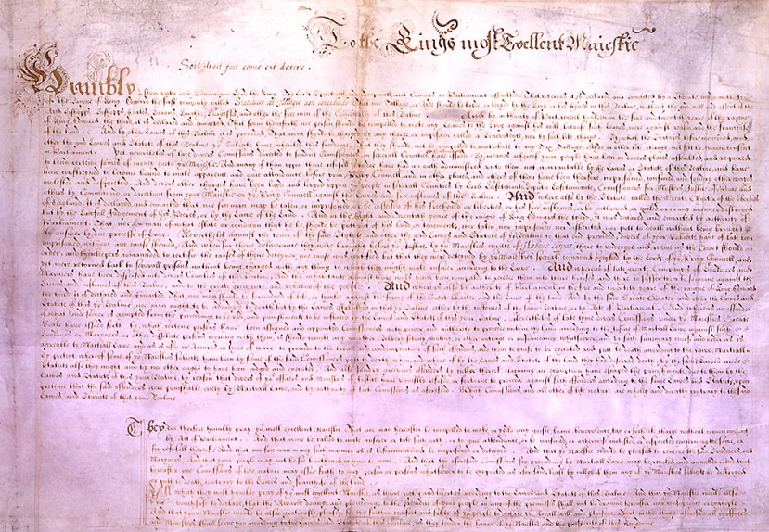
Demands Made:
- that no freeman should be forced to pay any tax, loan, or benevolence, unless in accordance with an act of parliament;
- that no freeman should be imprisoned contrary to the laws of the land;
- that soldiers and sailors should not be billeted on private persons;
- commissions to punish soldiers and sailors by martial law should be abolished.

Excerpt: “And whereas by the statute called the ‘Great Charter of the Liberties of England’ [Magna Carta] it is declared that no freeman may be imprisoned, or [relieved] of his land or liberties, or be outlawed and exiled, except by lawful judgement of his peers, or by the law of the land, yet many of your subjects have been imprisoned without any cause shown. They were detained by your Majesty’s special command in defiance of writs of habeaus corpus, and were returned to prison, without being charged with anything to which they might answer according to law.”

What complaint is the Parliament making? What specific things has Charles I been doing? Where is there reference to the Magna Carta?

