The War of 1812 Board Game
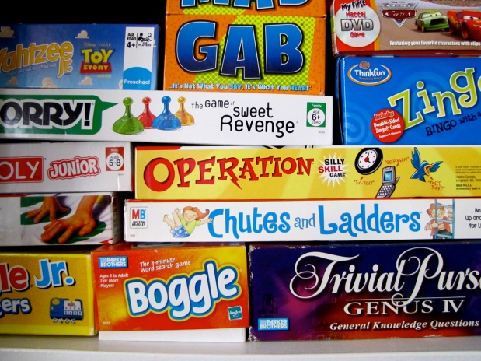
With your knowledge of the themes, conflicts, and events surrounding the war of 1812, you will work in small groups (2-4 players) to create a playable board game.
As you can see above, there are many different types of games. You are REQUIRED, however, to include historical detail and fact in your creation.

PLEASE INCLUDE:
- Causes of the War of 1812
- Participants of the War of 1812 (heroes?)
- Aboriginal, British, American, British North American (Canada) perspective
- Equality rights (slavery, women, aboriginal land rights)
- Events of the War of 1812
- Appropriate terminology (i.e. loyalist, patriots, etc.)
- Consequences of the War of 1812
- Evidence of using notes and some external research
  - Include a BIBLIOGRAPHY
- A clear set of instructions to a playable game

This project will be due before March break (spring break). Class time will be allocated towards its completion.
Criterion A: Knowing and Understanding
(0) | Beginning (1-2) | Developing (3-4) | Accomplished (5-6) | Exemplary (7-8)
I have not achieved a standard described by any of the descriptors to the right. | I am able to:  use limited relevant terminology  demonstrate basic knowledge and understanding of content and concepts with minimal descriptions and/or examples. | I am able to:  use some terminology accurately and appropriately  demonstrate adequate knowledge and understanding of content and concepts through satisfactory descriptions, explanations and examples. | I am able to:  use a range of terminology accurately and appropriately  demonstrate substantial knowledge and understanding of content and concepts through accurate descriptions, explanations and examples. | I am able to:  consistently use a wide range of terminology effectively  demonstrate detailed knowledge and understanding of content and concepts through thorough, accurate descriptions, explanations and examples.
Criterion B: Investigating
(0) | Beginning (1-2) | Developing (3-4) | Accomplished (5-6) | Exemplary (7-8)
I have not achieved a standard described by any of the descriptors to the right. | I am able to:  formulate a research question that is clear or focused and describe its relevance  formulate a limited action plan to investigate a research question or does not follow a plan  collect and record limited information, not always consistent with the research question | I am able to:  formulate a research question that is clear and focused and describes its relevance in detail  formulate and somewhat follow a partial action plan to investigate a research question  uses a research method(s) to collect and record mostly relevant information | I am able to:  formulate a clear and focused research question and explain its relevance  formulate and follow a substantial action plan to investigate a research question  use research method(s) to collect and record appropriate, relevant information | I am able to:  formulate a clear and focused research question and justify its relevance  formulate and effectively follow a comprehensive action plan to investigate a research question  use research methods to collect and record appropriate, varied and relevant information
Criterion C: Communicating
(0) | Beginning (1-2) | Developing (3-4) | Accomplished (5-6) | Exemplary (7-8)
I have not achieved a standard described by any of the descriptors to the right. | I am able to:  communicate information and ideas in a limited way, using a style that is limited in its appropriateness to the audience and purpose  structure information and ideas according to the specified format in a limited way  document sources of information in a limited way. | I am able to:  communicate information and ideas satisfactorily by using a style that is somewhat appropriate to the audience and purpose  structure information and ideas in a way that is somewhat appropriate to the specified format  sometimes document sources of information using a recognized convention. | I am able to:  communicate information and ideas accurately by using a style that is mostly appropriate to the audience and purpose  structure information and ideas in a way that is mostly appropriate to the specified format  often document sources of information using a recognized convention. | I am able to:  communicate information and ideas effectively and accurately by using a style that is completely appropriate to the audience and purpose  structure information and ideas in a way that is completely appropriate to the specified format  consistently document sources of information using a recognized convention.
Criterion D: Thinking Critically
(0) | Beginning (1-2) | Developing (3-4) | Accomplished (5-6) | Exemplary (7-8)
I have not achieved a standard described by any of the descriptors to the right. | I am able to:  analyse concepts, issues, models, visual representation and theories to a limited extent  summarize information to a limited extent to make arguments  identify different perspectives and minimal implications. | I am able to:  analyse concepts, issues, models, visual representation and theories  summarize information to make arguments  interpret different perspectives and some of their implications. | I am able to:  discuss concepts, issues, models, visual representation and theories  synthesize information to make valid arguments  values and limitations  interpret different perspectives and their implications. | I am able to:  complete a detailed discussion of concepts, issues, models, visual representation and theories  synthesize information to make valid, well-supported arguments  thoroughly interpret a range of different perspectives and their implications.

You will be assessed with the following rubric. Ensure there is an even divide of labour.

