History of the French Flag
From: http://www.francethisway.com/info/franceflag-history.php
During the Ancien Régime, the oriflamme, the flag of Saint-Denis, was used -- red, with 2, 3 or 5 spikes. Originally, it was the personal flag of Charlemagne, given to him by the Pope in the 9th century. Over time, it became the royal banner under the Carolingians and the Capetians. It was stored in Saint-Denis abbey, where it was taken when war broke out.
In the French military, every regiment had its own flag. An accident where French regiments attacked each other at the Battle of Fleurus in 1690 led to the habit of attaching a white scarf to the flags of the regiments -- white being the colour of the kings of France.
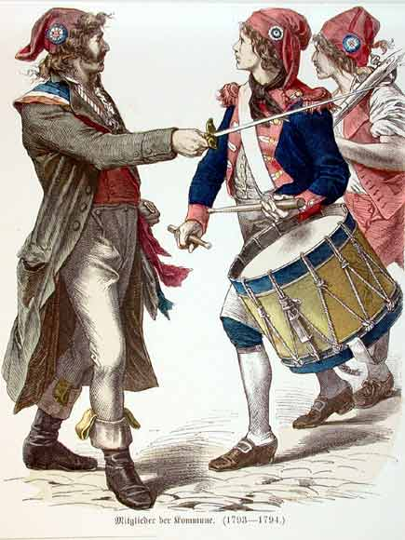
The origins of the tricolore are said to be a rosette, created in July 1789 during the French Revolution, which (according to legend among vexillologists) used a combination of the colours of the coat of arms of Paris (red and blue), symbolically separated by the royal colour (white), with the combination often being credited to the Marquis de Lafayette. There are many theories and suppositions about the choice of colours and indeed Lafayette's involvement in the process.
One theory says that Lafayette was inspired by the colours used by the American revolutionaries; another that it symbolized the control of the people over the monarchy (Paris' colours - blue and red - bording monarchy's colour - white) at a time when parliamentary monarchy was still seen as a possibility in France; another that the French design and scheme originated with the Dutch flag - the first tricolour….
[The flag from that point on continued to be used with various adaptations, including adding symbols in the middle as recently as WWI. Conversely, some navies in the late 18th century flew a white flag for the monarchy.]

Name: Block:
Liberté, égalité, fraternité
During the French Revolution 1787-1799, "Liberty, Equality, Fraternity" was one of many mottos used by revolutionaries to unite and inspire them.
It is a tripartite motto, consisting of three words/ideas. It was inspired from the ideas of the Enlightenment, and from philosophes like Rousseau. Events and documents produced from the English Civil War and the American Revolution also provided inspiration.
Robespierre advocated in a speech on the organization of the National Guards (in December 1790) that the words "The French People" and "Liberty, Equality, Fraternity" be written on uniforms and flags, but his proposal was rejected.
From 1793 onwards, the words "Unity, indivisibility of the Republic; liberty, equality or death" could be seen painted on the façades of Parisian houses. People in other cities soon followed suit, but they removed the word death, as it invoked memories of the Terror (The Terror was the most bloody time of the Revolution with mass executions taking place either by firing squads, cannon fire or guillotine).

TASK:
With your group, come up with three distinct flags AND mottos for the three distinct groups of the Three Estates. Consider what was most important to each group, what they would be fighting for during the revolution, and any previously used symbolism (either in images or in wording). Use the information above, on the reverse (regarding the tricolor), and the separate handout (on the Three Estates) to help with your design.
Be prepared to explain your design choices!

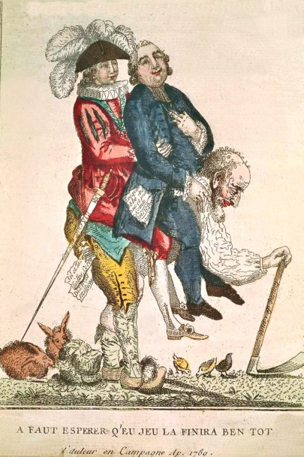
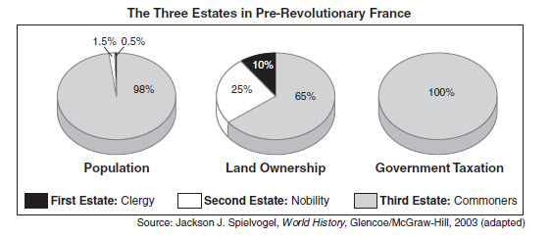
The Three Estates
First Estate
- CLERGY
-considered highest on the social ladder
-possessed an enormous amount of power
-made up .5% of the population
-owned 10% of all the land in France
*Not required to pay taxes*

Second Estate
-NOBLES
-made up 1.5% of the population
-the richest of the nobility held top jobs in government, army, courts
*Not required to pay taxes*

Although the Second Estate was considered to be the nobility there were some that were poor, many had some wealth, and a few were filthy rich. Both the First Estate and
Second Estate did not want anything to change in France unless there was chance they could gain more political power.

Third Estate
98% of the population
◊many different groups of people

Top
-BOURGEOISIE
-middle class
-bankers
-merchants
-lawyers
-doctors
-journalists
-professors

Middle
-PEASANTS
-9/10 people in class

Bottom
-CITY WORKERS
overworked and underpaid objected the most to the living conditions & politics in Fr became known as the sans culottes because of the way they dressed and their support for the French Revolution
**REQUIRED TO PAY TAXES**

