Viking Assignment

Your job is to create an artifact that informs your understanding of the Vikings. While we have some evidence of Viking settlements left behind, we have very limited understanding of written records because they didn’t write in Latin, but instead used ruins.
You are going to display your understanding of the Viking period by creating your own artifact. You may choose any one of the options below. If you have a different suggestion, please come to me to get permission before you start.
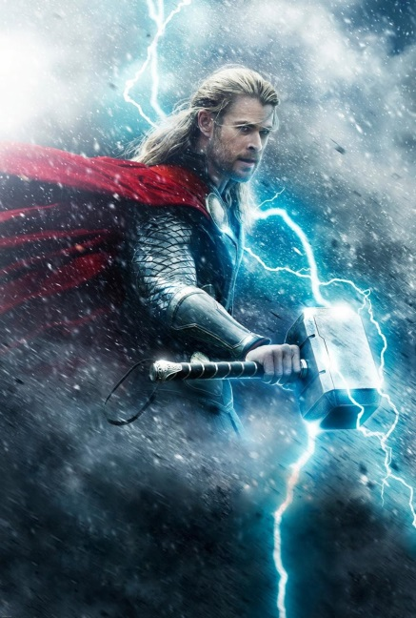
You may need to do some research outside of the links that I have provided. Once you have completed your artifact, you will also provide me a written paragraph explaining how your artifact reveals information about the Viking period.

OPTIONS:
- a monastic chronicle explaining Viking activity from a Monk’s perspective
- a Danish coin with ruins
- an Icelandic saga of a Viking warrior or Leader
- a Viking recipe with an analysis of ingredients
- an illustration of a Pagan Myth
- other?

POTENTIAL REFERENCES:
BBC, “Viking Religion”: http://www.bbc.co.uk/history/ancient/vikings/religion_01.shtml
BBC, “How do we know about the Vikings”: http://www.bbc.co.uk/history/ancient/vikings/evidence_01.shtml
“Viking Recipes”: http://nvg.org.au/documents/other/vikingrecipes.pdf
Viking Ship Museum, “Written Sources for the Viking Age”: http://www.vikingeskibsmuseet.dk/en/the-sea-stallion-past-and-present/archaeology-and-history/written-sources-for-the-viking-age/#.VhfK_G6DF2A

