Name: Block:
WebQuest: Feudalism and Manorialism
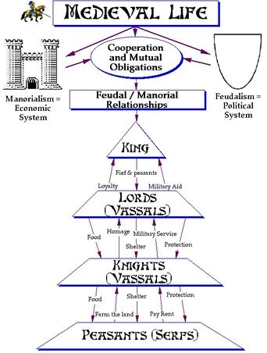
Review the feudal and manorial relationships. Why would this system work? Why would peasants continue to farm the land and pay rent? Why would lords need knights?

Go to http://www.bbc.co.uk/history/british/normans/doomsday_01.shtml (search ‘BBC Domesday Book’)
Why was the Domesday Book made?

What were some questions they asked?

Who are the ‘villani’?

Go to http://opendomesday.org/ (Open Domesday).
Determine the total population and tax assessed for Grantham, Ellesmere, and Mucklestone.

Why would there be such a difference in value?

Find one other place of your interest, and record the ‘households’ and ‘ploughland’:

Go to http://www.mylearning.org/medieval-grantham/p-/resource/2519/ (Medieval Grantham Map Activity) and open the PowerPoint.
Where does the name ‘Grantham’ come from?

Who were the ‘burgesses’? How many were there? What did their land look like?

When was the school built? The hospital?

What are tofts and crofts?

Make a sketch below of Grantham. Make sure to include and label: church, market, and public house.

