Name: Block:
Western Art through the Ages
Below are 3 key pieces from 3 different time periods. After watching the introductory video, decide what sort of values are held by the people that made these pieces of art. What do they find important? What topic are they focused on? What are they trying to convey?
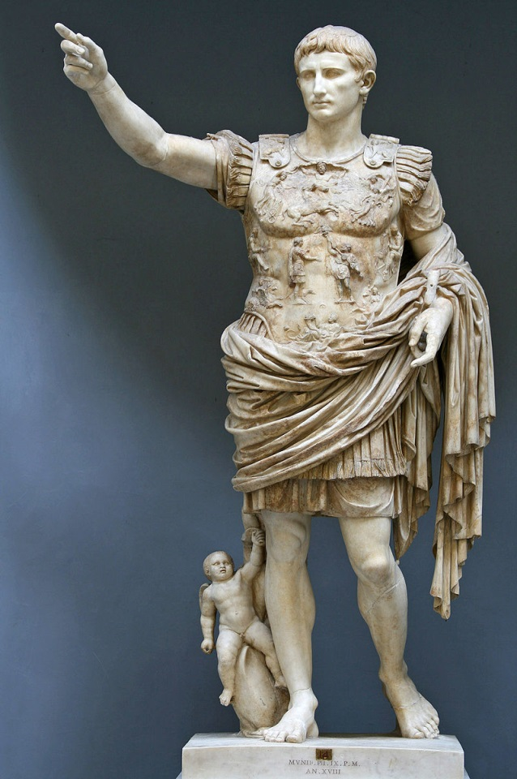
ROMAN ART
Augustus of Prima Porta, statue of the emperor Augustus, 1st century AD, Vatican Museums

What/Who is the subject?
How is this person conveyed?
What values could this society hold? How do you know?
Any other ideas?

MEDIEVAL ART
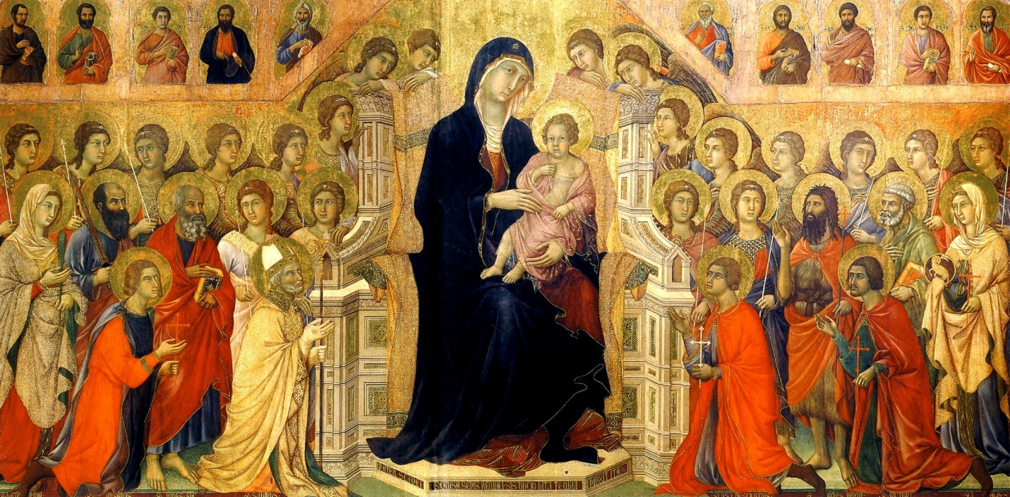
The central panel of Duccio’s huge Maesta altarpiece for Siena Cathedral.

What/Who is the subject?
How is this person conveyed?
What values could this society hold? How do you know?
Any other ideas?
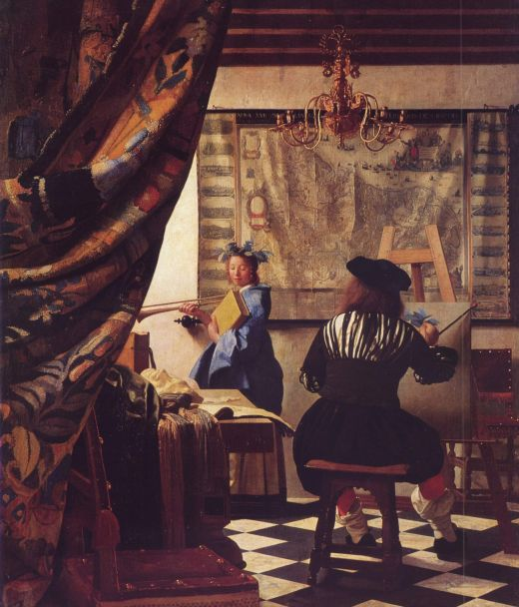
RENAISSANCE ART
Johannes Vermeer (1632-1675), "The Art of Painting" created in 1665, in a museum in Vienna.
What/Who is the subject?
How is this person conveyed?
What values could this society hold? How do you know?
Any other ideas?

FINAL THOUGHTS: WHAT CAN WE LEARN ABOUT CULTURE FROM VIEWING ART?

Task: Contemporary Art/Advertisement Analysis
In the video we watched, it was suggested that most art is only used to sell products. Find an artwork from the last 100 years and explain what the purpose of the art is – is it intended to sell a product or is it intended to do something else? What sorts of values are reflected on our own society? Answer in complete sentences.
Provide a description of the art piece and the artist in your response.

