What makes a Renaissance man?

A painting by Sir Winston Churchill has sold for £1.8m – so why are some people brilliant at everything? By Olivia Goldhill (The Telegraph, 18 Dec 2014)
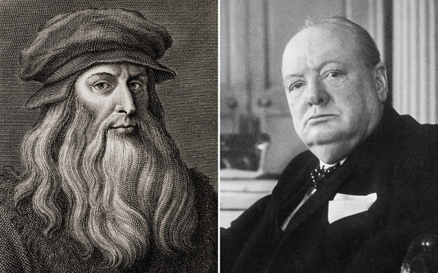
Renaissance men: Leonardo da Vinci and Sir Winston Churchill Photo: Rex/Getty

If Churchill hadn’t been prime minister during World War Two, he would still be one of the most accomplished men of the past century. The great wartime leader won the Nobel Prize for Literature in 1953 and one of his paintings recently sold for £1.8m.
Polymaths – those who have expertise in many different areas – are known as Renaissance men, because so many all-round geniuses emerged in the period. The painter/ scientist/ philosopher/ engineer Leonardo da Vinci is the archetypal example – but what leads some people to be brilliant at everything?
Geniuses are incredibly rare (some argue there are no more than one genius per million people), and it seems inconceivable that a brilliant physicist could also be a first-rate musician.
But Robert Plomin, professor of behavioural genetics at King’s College London, argues that those with exceptional intelligence tend to be brilliant in many areas, not just one. “If you’re smarter then you think more strategically, regardless of the role,” he says. “The idea is, if you're very smart then you play your cards better.”
Somebody who excels – whether in sports, music or the arts – tends to have above average IQ. And those who insist that they’re brilliant in just one subject aren’t simply being modest – they consider their other talents to be poor compared to their greatest achievement.
“People will often say, ‘I’m good at this but no good at that’, but really what they mean is that they’re less relatively good at the other thing. Compared to everybody, they’re actually good in both,” says Plomin.
The stereotype of a scientist with no social skills or appreciation for the arts is nothing more than a myth. “A lot of people think that boffins are only good at one thing. I think that’s a bit of envy,” says Plomin. “People say, ‘They’re good at that but horrible human beings’, and that's generally not true.”
But although geniuses may have the potential to be brilliant in many ways, we can only measure performance, not abstract ability. The contemporary focus on specialisation means that modern geniuses aren’t encouraged to expand their knowledge in the same way as Renaissance men.
An Aesop’s fable tells the tale of a hedgehog who knows a lot about one little subject, and a fox who knows a little about a lot of subjects – academia today seems more receptive to hedgehogs than foxes, says Plomin.
“Nowadays the training is so specialised, they wouldn’t let you develop talent in other areas. But the big advances come from the foxes who know a little bit about a lot of things and can put two and two together, rather than the hedgehogs in the trenches who are burrowing away and trying to find out more and more about less,” he says.
Of course, most of us would love the chance to be a hedgehog and be considered a genius in our field. But if you’re already a hedgehog then it’s difficult not to wonder: how does the world look from the perspective of a fox?

According to the author, why can’t modern people become “Renaissance Men”?

Do you agree with the author? Why or why not?

