World Religion Project
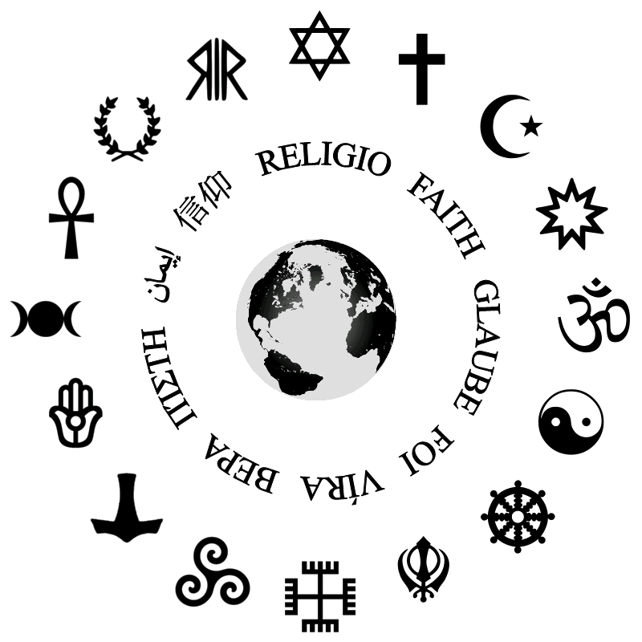
Your job will be to investigate ONE religion in ONE country. You will provide the historical background to this religion and explain what it looks like today.
For example, you may want to examine Buddhism in Thailand.
You may choose to present your findings to the class in multiple ways: through a poster board, through a powerpoint or prezi, or through a video. Talk to me first to check if your idea will work.
You must write all of your information in your own words – copying text is not acceptable!
You may work with a partner, but you must ensure that each partner has divided the work evenly.
The following are elements that you should include:
how it started, important religious figures, important dates, religious deities, religious practices, important dates, important texts, religious celebrations, different branches, important images/artifacts, number of practitioners (and more! For instance, you could include an interview with a follower of that religion.)
PLEASE REMEMBER THAT WE LIVE IN A DIVERSE WORLD, WITH MANY DIFFERENT BELIEFS AND PRACTICES. TOLERANCE IS A MUST!

