Write Your Own Feudal Contract:
In-Class Assignment

We have just studied an authentic primary source of a Feudal Contract. We know that vassals offered their lords many things in exchange for their fief and protection. We also know that this agreement between lord and vassal was taken seriously and these promises were rarely broken.

In this assignment, you will write up a Feudal Contract in groups of two (2). You will write the Feudal Oath of both the lord and the vassal together. Your contract can be between:

- Monarch (King or Queen) & Noble (Duke, Earl, Baron, Duchess, Baronness, or Lady)
- High Noble (Male or Female) & Lesser Noble (Male or Female)
- Noble (Male or Female) & Knight (Male - Sir)
- Noble (Male or Female) & Vassal (Non-Noble)

You will need to make up Medieval names for your lord and vassal. For example: Lady Lucia of Kerrisdale or King O`Connor of the Classroom, if your lord and vassals are nobles. *If you choose to write as a non-noble vassal, your name will be simple, such as Tyler of Kitsilano.

What you offer each other must be appropriate for your social status. If you are a Monarch you can offer anything: land, gold, or a Title; if you are a knight you will certainly offer military service, although what kind and how often may vary; if you are a non-noble vassal, you do not have much money or possessions of any great value so you will offer goods and services including: grain, poultry, tool or machine repair, house cleaning, animals, vegetables or field work. Each character must think about what the other would value.

You can use modern names of people and places and even modern goods in your Feudal Oaths. However, try to use the same medieval language and phrasing modeled in the authentic examples we have read.

Your assignment requires 4 parts:
- Describe the fief (the fee or reward that the lord gives to the vassal)
Example: I, Queen Margaret of Manitoba, grant you a fief in Vancouver including a carwash, McDonald`s, 3 miles of beach and a yacht…

- Describe the services provided by the vassal in return
Example: I, Baroness Michelle of Downtown Vancouver, will provide to you, the Queen Margaret of Manitoba, a king-sized bed in my condo whenever you may choose to visit, espresso every morning, a butler and free dry cleaning of all of your robes…

- Describe what will happen if you break your promises
Example: If I, Baroness Michelle of Downtown Vancouver, or any of my successors do not observe to thee each and all of the promises here declared, then I shall grant you my collection of designer handbags, my Mercedes Benz, and my firstborn child to act as your personal assistant as long as you both shall live.

- Your signatures
- Presentation: Flip a coin to decide who will read the part of the Lord and who will play the Vassal. You will act out your contract in front of the class by swearing on a ``holy object``. (read instructions sheet for specific directions).
Write Your Own Feudal Contract:
Instructions

- Pick a Lord and a Vassal. Give your parties (participants) Medieval names.

- On a sheet of lined paper, write a draft of the Lord`s contract & decide on a fief (the fee or reward offered to the vassal).

- Based on the fief, write a draft of the oath of the vassal. Decide what the vassal would have to give to the Lord in return, to make an even exchange and write their oath on lined paper.
Example: If the King of Point Grey offers the entire school as a fief to a knight, Sir Justin Bieber of Hollywood, Sir Justin Bieber cannot simply give him a CD in return – he must offer enough military service and other things until the trade is fair.

- Decide on consequences for both parties if one were to break the oath and include those on your drafts.

- Re-Write your good copies of the contracts on the Medieval ``scrolls`` provided.
- Pick a ``Holy Object``. In the High Middle Ages, oaths were often sworn on a sacred object. This can be anything you really value, like your iPod or cellphone (I know how much you value those!)

- Decide who will read the part of the lord and who will read the part of the vassal in front of the class. Both parties will place their hand on the sacred object when they read their oath, but the vassal will get down on one knee. After reading your part, you will sign your oaths. If you cannot agree on a role, flip a coin. If you still do not agree I will choose for you.

Write Your Own Feudal Oath!:
More Primary Source Examples

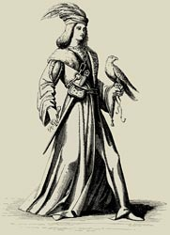
13th century France - Fealty Oath of John of Toul (a Lord)
I, John of Toul, make known that I am the liege man of the lady Beatrice, countess of Troyes, and of her son, Theobald, count of Champagne, against every creature, living or dead, saving my allegiance to lord Enjorand of Coucy, lord John of Arcis, and the count of Grandpré. If it should happen that the count of Grandpré should be at war with the countess and count of Champagne on his own quarrel, I will aid the count of Grandpré in my own person, and will send to the count and the countess of Champagne the knights whose service I owe to them for the fief which I hold of them.

But if the count of Grandpré shall make war on the countess and the count of Champagne on behalf of his friends and not in his own quarrel, I will aid in my own person the countess and count of Champagne, and will send one knight to the count of Grandpré for the service which I owe him for the fief which I hold of him, but I will not go myself into the territory of the count of Grandpré to make war on him.

Signed by the grace of God in the reign of Louis, John of Toul

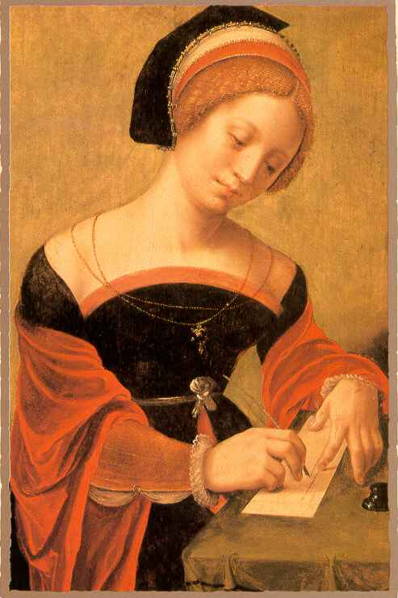
1201 Feudal Contract of Blanche of Navarre, Countess of Champagne
(after Theobald's death)

I, Blanche, Countess palatine of Troyes. Be it known to all, present and future, that I have voluntarily sworn to my lord, Philip, king of France, to keep the agreements contained in this charter.... I have voluntarily sworn that I will never take a husband without the advice, consent, and wish of my lord, Philip, king of France, and that I will place under his guardianship my daughter and any child of whom I may be pregnant from my late husband, count Theobald.

In addition, I will turn over to him the fortresses of Bray and Montereau, and give him control of all the men who dwell there and all the knights who hold fiefs of the castles, so that if I break my promise to keep these agreements, all the aforesaid men shall hold directly of my lord, Philip, king of France; They shall swear to aid him against men and against every other man or woman.

The lord of Marolles shall put himself and his castle also under the control of the king, and similarly all the knights who hold fiefs of Provins, and all the men of Provins, and all the men of Lagny and Meaux, and all the knights who hold fiefs of these places.... I will do liege homage to my lord, Philip, king of France, and I will keep faith with him against all creatures, living or dead.

Enacted in Troyes, in the year of grace 1201, in the month of August
Blanche of Navarre, Countess of Champagne

